Telusko: Core Java 08

071 Generics in Java

keyPoints abount BoundedTypes
==========================
=> As the type parameter we can use any valid java identifier but it convention to
use T always.
eg: class Test<T>{}
class Test<iNeuron>{}
=> We can pass any no of type parameters need not be one.
eg: class HashMap<K,V>{}
HashMap<Integer,String> h=new HashMap<Integer,String>();
Which of the following are valid?
class Test <T extends Number&Runnable> {}//valid
Number -> class
Runnable-> interface
class Test<T extends Number&Runnable&Comparable> {} //valid
Number -> class
Runnable-> interface
Comparable -> interface
class Test<T extends Number&String> {} //invalid
we can't extends more than one class at a time.
class Test<T extends Runnable&Comparable> {} //valid
Runnable-> interface
Comparable -> interface
class Test<T extends Runnable&Number> {}//invalid
Runnable-> interface
Number -> class
rule: first inherit and the implement so invalid
GenericClass
==========
class: Type parameter
Can we apply TypeParameter at MethodLevel?
Ans.Yes, it is possible.
Generic methods and wild-card character (?)
======================================
1. methodOne(ArrayList<String>al):
This method is applicable for ArrayList of only String type.
methodOne(ArrayList<String> al){
al.add("sachin");
al.add("navinreddy");
al.add("iNeuron");
al.add(new Integer(10));//invalid
}
Within the method we can add only String type of objects and null to the List.
2. methodOne(new ArrayList<String>());
methodOne(new ArrayList<Integer>());
methodOne(new ArrayList<Runnable>());
|
|ArrayList<?> l =new ArrayList<String>();|
methodOne(ArrayList<?> l):
We can use this method for ArrayList of any type but within the method
we can't add anything to the List except null.
Example:
l.add(null);//(valid)
l.add("A");//(invalid)
l.add(10);//(invalid)
This method is useful whenever we are performing only read operation.
3. methodOne(ArrayList<? extends X> al)
X -> class, we can make a call to method by passing ArrayList of X type or
its Child type.
X -> interface, we can make a call to method by passing ArrayList of X type
or its Implementation class.
methodOne(ArrayList<? extends X> al){
al.add(null);
}
Best suited only for read operation.
4. methodOne(ArrayList<? super X> al)
X -> class, we can make a call to method by passing ArrayList of X type or
its super class
X -> interface, we can make a call to method by passing ArrayList of X type
or its super class of implementation class of x.
methodOne(ArrayList<? super X> al){
al.add(X);
al.add(null);
}
Which of the following declarations are allowed?
1. ArrayList<String> l1=new ArrayList<String>();//valid
2. ArrayList<?> l2=new ArrayList<String>();//valid
3. ArrayList<?> l3=new ArrayList<Integer>();//valid
4. ArrayList<? extends Number> l4=new ArrayList<Integer>();//valid
5. ArrayList<? extends Number> l5=new ArrayList<String>();//invalid
6. ArrayList<?> l6=new ArrayList<? extends Number>(); //invalid
7. ArrayList<?> l7=new ArrayList<?>(); //invalid
TypeParameter at Method level
==========================
|=> TypeParameter at the class level
class Demo<T>{
|=> Type parameter defined just before the return type
public <T> void m1(T t){}
}
Which of the following declarations are allowed?
public <T> void methodOne1(T t){}//valid
public<T extends Number> void methodOne2(T t){}//valid
public<T extends Number&Comparable> void methodOne3(T t){}//valid
public<T extends Number&Comparable&Runnable> void methodOne4(T t){}//valid
public<T extends Number&Thread> void methodOne(T t){}//invalid
public<T extends Runnable&Number> void methodOne(T t){}//invalid
public<T extends Number&Runnable> void methodOne(T t){}//valid
Communication with non generic code
===============================
To provide compatibility with old version sun people compramized the concept of
generics in very few area's the
following is one such area.
Example:
importjava.util.*;
class Test{
public static void main(String[] args){
ArrayList<String> l=new ArrayList<String>();
l.add("sachin");
//l.add(10);//C.E:cannot find symbol,method add(int)
methodOne(l);
l.add(10.5);//C.E:cannot find symbol,method
add(double)
System.out.println(l);//[sachin, 10, dhoni, true]
}
public static void methodOne(ArrayList l){
l.add(10);
l.add("dhoni");
l.add(true);
}
Conclusions :
Generics concept is applicable only at compile time, at runtime there is no such
type of concept.
At the time of compilation, as the last step generics concept is removed,hence for
jvm generics syntax won't be available.
Hence the following declarations are equal.
ArrayList l=new ArrayList<String>();
ArrayList l=new ArrayList<Integer>();
ArrayList l =new Arraylist<Double>();
All are equal at runtime,becoz compiler will remove these generics syntax
ArrayList l=new ArrayList();
Example 1:
import java.util.*;
class Test {
public static void main(String[] args) {ArrayList l=new ArrayList<String>();
l.add(10);
l.add(10.5);
l.add(true);
System.out.println(l);// [10, 10.5, true]
}
}
Example 2:
import java.util.*;
class Test {
public void methodOne(ArrayList<String> l){}
public void methodOne(ArrayList<Integer> l){}
}
CE: duplicate methods found
Behind the scenes by the compiler
=============================
1. Compiler will scan the code
2. Check the argument type
3. if Generics found in the argument type remove the Generics syntax
4. Compiler will again check the syntax
Example3:
The following 2 declarations are equal.
ArrayList<String> l1=new ArrayList();
ArrayList<String> l2=new ArrayList<String>();
For these ArrayList objects we can add only String type of objects.
l1.add("A");//valid
l1.add(10); //invalid
Comparable vs Comparator
=======================
public TreeSet();
|=> When we use the above constructor,JVM will internally use
Comparable interface method to sort the Objects
based on default natural sorting order.
What is Comparable interface?
It is a functiaonal interace present in java.lang package.
This interface is internally used by TreeSet object during sorting process of
the Object.
@FunctionalInterface
public interface java.lang.Comparable<T> {
public abstract int compareTo(T);
}
eg#1.
import java.util.*;
class Test
{
public static void main(String[] args)
{
//Sorting of objects will happen based on default natural sorting order
TreeSet ts = new TreeSet();ts.add("A");
ts.add("Z");
ts.add("L");
ts.add("B");
ts.add(null);//NullPointerException
ts.add(10);//ClassCastException
System.out.println(ts);//[A,B,L,Z]
}
}
Note:
If we are keeping the data inside TreeSet object, then the data should be
a. Homogenous ====> because it uses compareTo() to sort the
b. The object should compulsorily implements an interface called
if we fail to do so , it would result in
Object
"Comparable".
"ClassCastException".
eg#2.
import java.util.*;
class Test
{
{
public static void main(String[] args)
//Sorting of objects will happen based on default natural sorting order
TreeSet ts = new TreeSet();
ts.add(new StringBuffer("A"));
ts.add(new StringBuffer("Z"));
ts.add(new StringBuffer("L"));
ts.add(new StringBuffer("B"));
System.out.println(ts);//ClassCastException
}
}
note: All Wraper classes and String class has implemented "Comparable" interface.
StringBuffere class has not implemented Comparable interface, so the
above program would
result in "ClassCastException".

Question 15:
What will be the result of compiling and executing Test class?
public class Test {
public static void main(String[] args) {
try {
main(args);//infinit-call to the same main()====>
StackOverFlowError(Child of Error)
} catch (Exception ex) {
System.out.println("CATCH-");
}
System.out.println("OUT");
}
}
A. CATCH-OUT
B. OUT
C. None of the System.out.println() will be executed
D. CompilationError.
Answer: C
Consider below code:
public class Test {
public static void main(String[] args) {
StringBuilder sb = new StringBuilder();//capacity = 16
try {
for(;;) {
sb.append("iNeuron");//memory in heaparea in
finite(OutOfMemoryError)==> Error class
}
} catch(Exception e) {
System.out.println("Exception!!!");
}
System.out.println("Main ends!!!");
}
}
What will be the result of compiling and executing Test class?
A. "Main ends!!!" printed on the console and program terminates succesfully.
B. "Exception!!!" and "Main ends!!!" printed on the console and program terminates
succesfully.
C. "Exception!!!" is printed on the console and program terminates succesfully.
D. "Exception!!!" is printed on the console and program terminates abnormally.
E. Program terminates abruptly.
Answer: E
Question 17:
What will be the result of compiling and executing Test class?
//Test.java
import java.io.FileNotFoundException;
public class Test {
public static void main(String[] args) {
try {
System.out.println(1);//Exception is not generated
} catch (NullPointerException ex) {
System.out.println("ONE");
} catch (FileNotFoundException ex) {//Fully Checked Excpetion
System.out.println("TWO");
}
System.out.println("THREE");}
}
A. ONE
THREE
B. TWO
THREE
C. THREE
D. None of the System.out.println() be executed
E. CompilationError
Answer:E
Question 18:
Consider codes of 3 java files:
//Class1.java
import java.io.FileNotFoundException;
public class Class1 {
public void read() throws FileNotFoundException {}//valid
}
//Class2.java
public class Class2 {//valid
String Class2;//valid
public void Class2() {}//it is a normal method
}
//Class3.java
public class Class3 {//invalid
private void print() {
private String msg = "HELLO";//inside a method only modifier permitted is
"final"
System.out.println(msg);
}
}
Which of the following statement is true?
A. Only Class1.java compiles succesfully
B. Only Class2.java compiles succesfully
C. Only Class3.java compiles succesfully
D. Class1.java and Class2.java compiles succesfully
E. Class1.java and Class3.java compiles succesfully
F. Class2.java and Class3.java compiles succesfully
Answer: D
Q>
What will be the result of compiling and executing Test class?
public class Test {
public static void main(String[] args) {
m1(); //Line 3
}
}
private static void m1() throws Exception { //Line 6
System.out.println("NOT THROWING ANY EXCEPTION"); //Line 7
}
A. CompilationError at Line 3
B. CompilationError at Line 7
C. CompilationError at Line 6D. NOT THROWING ANY EXCEPTION
Answer: A
Question 20:
Consider below code:
public class Test {
static {
System.out.println(1/0);
}
public static void main(String[] args) {
System.out.println("HELLO");
}
}
On execution, does Test class print "HELLO" on to the console?
A.HELLO is printed on the console
B.NO Hello is not printed on the console
Answer: java.lang.ExcpetionInIntializerError

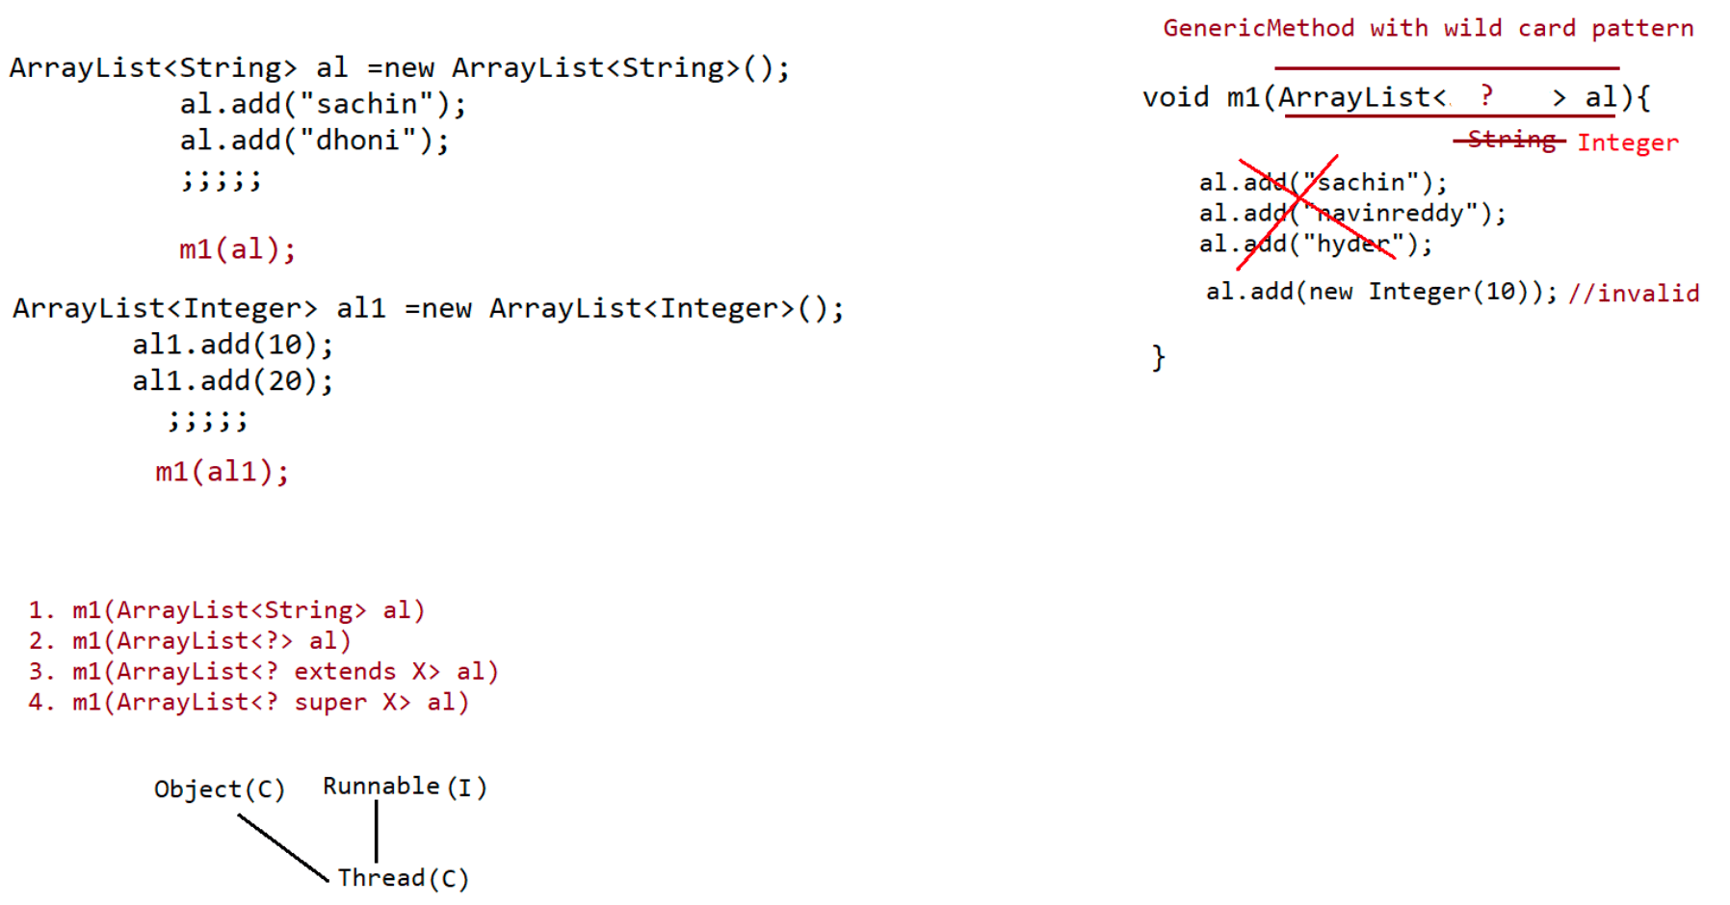

072 DOUBT
ArrayList l = new ArrayList();
l.add(10);
10===> java.lang.Integer
System.out.println(l.get(0).getClass().getName());
the output is Integer class.
sir explain little bit about servlet exception?
ServletExeception
|=> Problem would occur when we work with ServletAPI
like class is not under public, constructor is not written, or
some problem with B.L
class Test
{
static int a = m1();
static {
System.out.println("Inside static block");
}
static int m1() {
System.out.println("from m1");
return 20;
}
public static void main(String[] args)
{
System.out.println("Value of a : "+a);
System.out.println("from main");
}
}
Few days back i asked you, what is the difference between import package and
inheritance.
You said you will discuss it later. Can you explain it now?
=> import
getting up the service of some other class to our current class,
where the service provider
class in not present in current folder.
=> inheritance
getting up the service of another class to our class to reduce the
code.
class Person{
public String name;
public char gender
public int age;
}
import java.io.*;
class Student extends Person{
public void display(){
}
FileOutputStream fos = new FileOutputStream("sample.txt");
}Is there any way to convert .class file to .java?
yes possible using DeCompiler will be shown using Lombok API
Also, when will you teach us about cmd prompt and OS?
OS====> for users it is GUI
Command promt-> it acts like a os for developers to run the application from
command prompt.

073 Comparator vs Comparable
Note:
If we are Depending on Default Natural Sorting Order Compulsory Objects should be
Homogeneous and Comparable.
Otherwise we will get RE: ClassCastException.
An object is said to be Comparable if and only if corresponding class implements
Comparable interface.
All Wrapper Classes, String Class Already Implements Comparable Interface. But
StringBuffer Class doesn't Implement Comparable Interface.
@FunctionalInterface
public interface Comparable<T> {
public abstract int compareTo(T);
}
obj1.compareTo(obj2)
|=> returns -ve value, if obj1 has to come before obj2
|=> returns +ve value, if obj1 has to come after obj2
|=> returns 0 value, if both obj1 and obj2 are equal
import java.util.*;
class Test {
public static void main(String[] args) {
TreeSet ts =new TreeSet();
ts.add("A");
ts.add("Z");
ts.add("L");
ts.add("K");
ts.add("B");
System.out.println(ts);
}
}
Comparable (I):
Comparable Interface Present in java.lang Package and it contains Only One Method
compareTo().
obj1.compareTo(obj2)
Returns –ve if and Only if obj1 has to Come Before obj2.
Returns +ve if and Only if obj1 has to Come After obj2.
Returns 0 if and Only if obj1 and obj2 are Equal.
eg#1.
System.out.println("A".compareTo("Z")); //-ve value
System.out.println("Z".compareTo("K")); // +value
System.out.println("Z".compareTo("Z")); // zero
System.out.println("Z".compareTo(null));//NPE
Wheneverwe are Depending on Default Natural Sorting Order and if we are trying to
Insert Elements then Internally JVM will
Call compareTo() to IdentifySorting Order.
TreeSet t = new TreeSet();
t.add(“K”);
t.add(“Z”); “Z”.compareTo(“K”);
t.add(“A”); “A”.compareTo(“K”);
t.add(“A”); “A”.compareTo(“A”);
System.out.println(t);//[A,K,Z] => Sorting is ascending orderNote:
For String default natural sorting order is "Ascending order".
For Number default natural sorting order is "Ascending order"
Comparator(I)
============
Note: If we are Not satisfied with Default Natural Sorting Order OR if Default
Natural Sorting Order is Not Already Available then
we can Define Our Own Sorting by using Comparator Object.
public interface java.util.Comparator<T> {
public abstract int compare(T, T);
public abstract boolean equals(java.lang.Object);
}
Comparator (I):
This Interface Present in java.util Package.
Methods: It contains 2 Methodscompare() and equals().
public int compare(Object obj1, Object obj2);
Returns –ve if and Only if obj1 has to Come Before obj2.
Returns +ve if and Only if obj1 has to Come After obj2.
Returns 0 if and Only if obj1 and obj2 are Equal.
public boolean equals(Object o);
Whenever we are implementing Comparator Interface Compulsory we should
Provide Implementation for compare().
Implementing equals() is Optional because it is Already Available to Our
Class from Object Class through Inheritance.
import java.util.*;
class TreeSetDemo {
public static void main(String[] args) {
TreeSet t = new TreeSet(new MyComparator());//line-1
t.add(10);
t.add(0);
t.add(15);
t.add(5);
t.add(20);
t.add(20);
System.out.println(t);//[20, 15, 10, 5, 0]
}
}
class MyComparator implements Comparator {
public int compare(Object obj1, Object obj2) {
Integer i1 = (Integer)obj1;
Integer i2 = (Integer)obj2;
if(i1 < i2)
return +1;
else if(i1 > i2)
return -1;
else
return 0;
}
}
At Line 1 if we are Not Passing Comparator Object as an Argument then Internally
JVM will Call compareTo(),
Which is Meant for Default Natural Sorting Order (Ascending Order).In this Case the Output is [0, 5, 10, 15, 20].
At Line 1 if we are Passing Comparator Object then JVM will Call compare() Instead
of compareTo().
Which is Meant for Customized Sorting (can be Ascending /Descending Order).
In this Case the Ouput is [20, 15, 10, 5, 0]
Various Possible Implementations of compare():
========================================
public int compare(Object obj1, Object obj2) {
Integer I1 = (Integer)obj1;
Integer I2 = (Integer)obj2;
return I1.compareTo(I2);
return -I1.compareTo(I2);
return I2.compareTo(I1);
return -I2.compareTo(I1);
return +1;
return -1;
return 0;
}
Output:
1. Ascending order
2. Descending order
3. Descending order
4. Ascending order
5. insertion order
6. reverse of insertion order
7. only first element will be inserted.
Write a Program to Insert String Objects into the TreeSet where the Sorting Order
is of Reverse of Alphabetical Order:
import java.util.*;
class TreeSetDemo {
public static void main(String[] args) {
TreeSet t = new TreeSet(new MyComparator());
t.add("sachin");
t.add("ponting");
t.add("sangakara");
t.add("fleming");
t.add("lara");
System.out.println(t);
}
}
class MyComparator implements Comparator {
public int compare(Object obj1, Object obj2) {
String s1 = obj1.toString();
String s2 = (String)obj2;
return s2.compareTo(s1);
//return -s1.compareTo(s2);
}
}
Write a Program to Insert StringBuffer Objects into the TreeSet where Sorting Order
is Alphabetical Order:
import java.util.*;
class TreeSetDemo {
public static void main(String[] args) {TreeSet t = new TreeSet(new MyComparator1());
t.add(new StringBuffer("A"));
t.add(new StringBuffer("Z"));
t.add(new StringBuffer("K"));
t.add(new StringBuffer("L"));
System.out.println(t);
}
}
class MyComparator1 implements Comparator {
publicint compare(Object obj1, Object obj2) {
String s1 = obj1.toString();
String s2 = obj2.toString();
return s1.compareTo(s2); //[A, K, L, Z]
}
}
Write a Program to Insert String and StringBuffer Objects into the TreeSet where
Sorting Order is Increasing Length Order.
If 2 Objects having Same Length then Consider their Alphabetical Order:
eg: A,ABC,AA,XX,ABCE,A
output: A,AA,XX,ABC,ABCE
import java.util.*;
class TreeSetDemo {
public static void main(String[] args) {
TreeSet t = new TreeSet(new MyComparator());
t.add("A");
t.add(new StringBuffer("ABC"));
t.add(new StringBuffer("AA"));
t.add("XX");
t.add("ABCE");
t.add("A");
System.out.println(t);
}
}
class MyComparator implements Comparator {
public int compare(Object obj1, Object obj2) {
String s1 = obj1.toString();
String s2 = obj2.toString();
int i1 = s1.length();
int i2 = s2.length();
if(i1 < i2)return -1;
else if(i1 > i2)return 1;
else return s1.compareTo(s2);
}
}
Note:
if we are use TreeSet(), then the condition is
a. Object should be homogenous.
b. Object should be comparable(class should implement Comparable(I)).
if we are use TreeSet(Comparator c) then what is the condition?
a. Object need not be homogenous.
b. Object need not implement Comparable.When to go for Comparable interface and When to go Comparator interface?
Ans. Predefined Comparable classes like String,Wrapper class ====> Default natural
sorting is already available
if we are not happy with natural sorting order, we want customization then
we need to go for "Comparator(I)".
For Predefined Non-Comparable class like StringBuffer => Comparator(I) is
used for both natural sorting order and
and customized sorting order.
For userdefined class like Employee,Student =====> Developer if he comes up
with own logic of sorting,then he should
implement Comparable(I) and give it as a ready made logic.
Nitin.M
======
{
class Employee implements Comparable
int id;
String name;
int age;
public int compareTo(Object obj){
//sorting is done based on "id"
;;;;;
}
}
If the developer who is using Employee class, if he is not interested with sorting
based on "id" given by the api, then he can
use "Comparator".
When we go for Comparable and When we go for Comparator:
Comparable Vs Comparator:
=> For Predefined Comparable Classes (Like String) Default Natural Sorting Order is
Already Available. If we are Not satisfied
with that we can Define Our Own Sorting by Comparator Object.
=> For Predefine Non- Comparable Classes (Like StringBuffer) Default Natural
Sorting Order is Not Already Available.
If we want to Define Our Own Sorting we can Use Comparator Object.
=> For Our Own Classes (Like Employee) the Person who is writing Employee Class he
is Responsible to Define Default Natural
Sorting Order by implementing Comparable Interface.
=> The Person who is using Our Own Class if he is Not satisfied with Default
Natural Sorting Order he can Define his Own
Sorting by using Comparator Object.
If he is satisfied with Default Natural Sorting Order then he can Use Directly
Our Class.
Write a Program to Insert Employee Objects into the TreeSet where DNSO is Based on
Ascending Order of EmployeeId and
Customized Sorting Order is Based on Alphabetical Order of Names:
DNSO -> Default Natural Sorting Order
import java.util.*;
class Employee implements Comparable {String name;
int eid;
Employee(String name, inteid) {
this.name = name;
this.eid = eid;
}
public String toString() { return name+"-----"+eid;}
public int compareTo(Object obj) {
int eid1 = this.eid;
Employee e = (Employee)obj;
int eid2 = e.eid;
if(eid1 < eid2) return -1;
else if(eid1 > eid2) return 1;
else return 0;
}
}
class Test {
public static void main(String[] args) {
Employee e1 = new Employee("sachin", 10);
Employee e2 = new Employee("ponting", 14);
Employee e3 = new Employee("lara", 9);
Employee e4 = new Employee("flintoff", 17);
Employee e5 = new Employee("anwar", 23);
TreeSet t = new TreeSet();
t.add(e1);
t.add(e2);
t.add(e3);
t.add(e4);
t.add(e5);
System.out.println(t);
TreeSet t1 = new TreeSet(new MyComparator());
t1.add(e1);
t1.add(e2);
t1.add(e3);
t1.add(e4);
t1.add(e5);
System.out.println(t1);
}
}
class MyComparator implements Comparator {
public int compare(Object obj1, Object obj2) {
Employee e1 = (Employee) obj1;
Employee e2 = (Employee) obj2;
String s1 = e1.name;
String s2 = e2.name;
return s1.compareTo(s2);
}
}
Comparison of Comparable and Comparator:
Comparable(I)
Present in java.lang Package
It is Meant for Default Natural Sorting Order.
Defines Only One Method compareTo()All Wrapper Classes and String Class implements Comparable Interface.
Comparator(I)
Present in java.util Package
It is Meant for Customized Sorting Order.
Defines 2 Methods compare() and equals().
The Only implemented Classes of Comparator are Collator and RuleBaseCollator.

Question
Consider below code:
public class Test {
static Double d1; // d1 =null
static int x = d1.intValue();// null.intValue() ---> NullPointerException
public static void main(String[] args) {
System.out.println("HELLO");
}
}
On execution, does Test class print "HELLO" on to the console?
A.Yes HELLO is printed on the console
B.NO Hello is not printed on the console
Answer: B
Question
Consider below code:
public class Test {
static Double d1; // static variable ====> d1 =null
int x = d1.intValue();//instance variable ====> only upon creating an object
public static void main(String[] args) {
System.out.println("HELLO");//HELLO
}
}
On execution, does Test class print "HELLO" on to the console?
A.Yes HELLO is printed on the console
B.NO Hello is not printed on the console
Answer: A
Question:
What will be the result of compiling and executing Test class?
public class Test {
public static void main(String[] args) {
Error obj = new Error();
boolean flag1 = obj instanceof RuntimeException; //Line n1
boolean flag2 = obj instanceof Exception; //Line n2
boolean flag3 = obj instanceof Error; //Line n3
boolean flag4 = obj instanceof Throwable; //Line n4
System.out.println(flag1 + ":" + flag2 + ":" + flag3 + ":" + flag4);
}
}
A. Compilation Error
B. false:false:true:true
C. false:true:true:true
D. true:true:true:true
E. false:true:true:false
Note: Error and RunTimeExcpetion no relation in hierarchy as parent and child
Error and Exception no relation in hierarchy as parent and child
Answer: A
String s = "sachin";
class Student{}
Student s1 = new Student();
System.out.println( s instanceof String);//trueSystem.out.println( s instanceof StringBuffer);//CE(String and StringBuffer no
relationship)
System.out.println( s1 instanceof Runnable);//false
System.out.println( null instanceof Stringbuilder);//false
Fill in the blanks for the definition of java.lang.Error class:
public class java.lang.Error extends ________________ {...}
A. RunTimeException
B. Exception
C. Throwable
Answer: C
Question>
Given code of Test.java file:
public class Test {
public static void main(String[] args) {
System.out.println(new RuntimeException()); //Line n1
System.out.println(new RuntimeException("HELLO")); //Line n2
System.out.println(new RuntimeException(new
RuntimeException("HELLO"))); //Line n3
}
}
A. Yes
B. No
Does above code compile successfully?
Answer: A
Question>
Given code of Test.java file:
interface ILogger {
void log();
}
public class Test {
public static void main(String[] args) {
ILogger [] loggers = new ILogger[2]; //Line n1 ==JVM ==> loggers[0] =null;
loggers[1] =null;
for(ILogger logger : loggers)
logger.log(); //Line n2 ====JVM====> NullPointerException
}
}
What will be the result of compiling and executing Test class?
A. Line n1 causes compilation error
B. Line n2 causes compilation error
C. Exception is thrown at runtime
D. No output is displayed but program terminates succesfully.
Answer: C
valid
====
class MyThread1 implements Runnable{}
class MyThread2 implements Runnable{}
Runnable[] runnable = new Runnable[2];
runnable[0] =new MyThread1();
runnable[1] =new Mythread2();

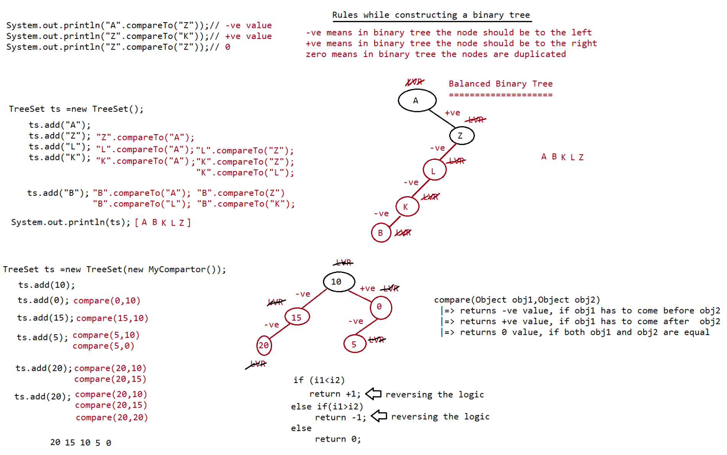

074 Functional interface and Stream API
Functional interfaces
=================
=> If an interface contains only one abstract method then such interfaces are
called as "Functional interface".
public interface java.util.function.Predicate<T> {
public abstract boolean test(T);
//default methods
public java.util.function.Predicate<T> and(java.util.function.Predicate<?
super T>);
public java.util.function.Predicate<T> negate();
public java.util.function.Predicate<T> or(java.util.function.Predicate<?
super T>);
//static method
public static <T> java.util.function.Predicate<T> isEqual(java.lang.Object);
}
Usage of Predicate
===============
class MyPredicate implements Predicate<Integer>
{
@Override
public boolean test(Integer i){
if (i>10)
return true;
else
return false;
}
}
Instead of writing a seperate class, we can write lambda expression as shown below
=====================================================================
class Test {
public static void main(String[] args){
Predicate<Integer> p =i->i>10
System.out.println(p.test(10));//false
System.out.println(p.test(100));//true
}
}
Write a Predicate to check whether the given String length is >=3 or not?
Instead of writing a seperate class, we can write lambda expression as shown below
=====================================================================
class MyPredicate implements Predicate<String>
{
@Override
public boolean test(String name){
if(name.length()>=3)
return true;
else
return false;
}
}
class Test {
public static void main(String[] args){Predicate<String> p = name -> name.length() >= 3;
System.out.println(p.test("PWC"));//true
System.out.println(p.test("CS"));//false
}
}
default methods available as utility methods for developer
===============================================
public default Predicate<T> and(Predicate p);
public defualt Predicate<T> negate();
public default Predicate<T> or(Predicate p);
import java.util.function.*;
public class Test {
public static void main(String[] args){
int[] arr = {0,5,10,15,20,25,30};
Predicate<Integer> p1 = i-> i>10;
System.out.println("Elements greater than 10 are :: ");
m1(p1,arr);
Predicate<Integer> p2 = i-> i%2==0;
System.out.println("Elements which are even no :: ");
m1(p2,arr);
even no");
even no");
System.out.println("Eleemnts which are greater than 10 and should be
m1(p1.and(p2),arr);
System.out.println("Eleemnts which are greater than 10 or should be
m1(p1.or(p2),arr);
System.out.println("The elements which are not even are :: ");
m1(p2.negate(),arr);
}
public static void m1(Predicate<Integer> p , int[] x){
for (int ele: x )
if (p.test(ele))//ele-> ele>10
System.out.println(ele);
}
}
Function(I)
=========
T-> input type
R-> return type
public interface java.util.function.Function<T, R> {
// 1 abstract method
public abstract R apply(T);
//default methodspublic <V> java.util.function.Function<V, R>
compose(java.util.function.Function<? super V, ? extends T>);
public <V> java.util.function.Function<T, V>
andThen(java.util.function.Function<? super R, ? extends V>);
//static method
public static <T> java.util.function.Function<T, T> identity();
}
Writing a code using Implementation class
===================================
class MyFunction implements Function<String,Integer>
{
@Override
public Integer apply(String name){
return name.length();
}
}
public class Test {
public static void main(String[] args){
Function<String,Integer> f = new MyFunction();
int output = f.apply("sachin");
System.out.println(output);
System.out.println("sachin".length());
}
}
Coding using LambdaExpression
===========================
public class Test {
public static void main(String[] args){
Function<String,Integer> f = name -> name.length();
int output = f.apply("sachin");
System.out.println(output);
}
}
Note:
When to go for Predicate and When to go for Function?
Predicate -> To implement some conditional checks we should go for Predicate
Function -> To perform some operation and to return some result we should go
for Function.
MethodReference(::) and Consturctor reference(::)
==========================================
:: ====> Scope resolution operator
syntax for method reference
========================
1. static method
ClassName::methodName
2. instance method
object:: methodName
eg#1.public class Test {
public static void m1(){
for (int i = 1;i<=10 ;i++ )
{
System.out.println("child thread");
}
}
public static void main(String[] args) throws Exception{
//using method reference binded the method call of run() of interface
Runnable
Runnable r = Test::m1;
Thread t =new Thread(r);
t.start();
for (int i = 1;i<=10 ;i++ )
{
System.out.println("main thread");
Thread.sleep(1000);
}
}
}
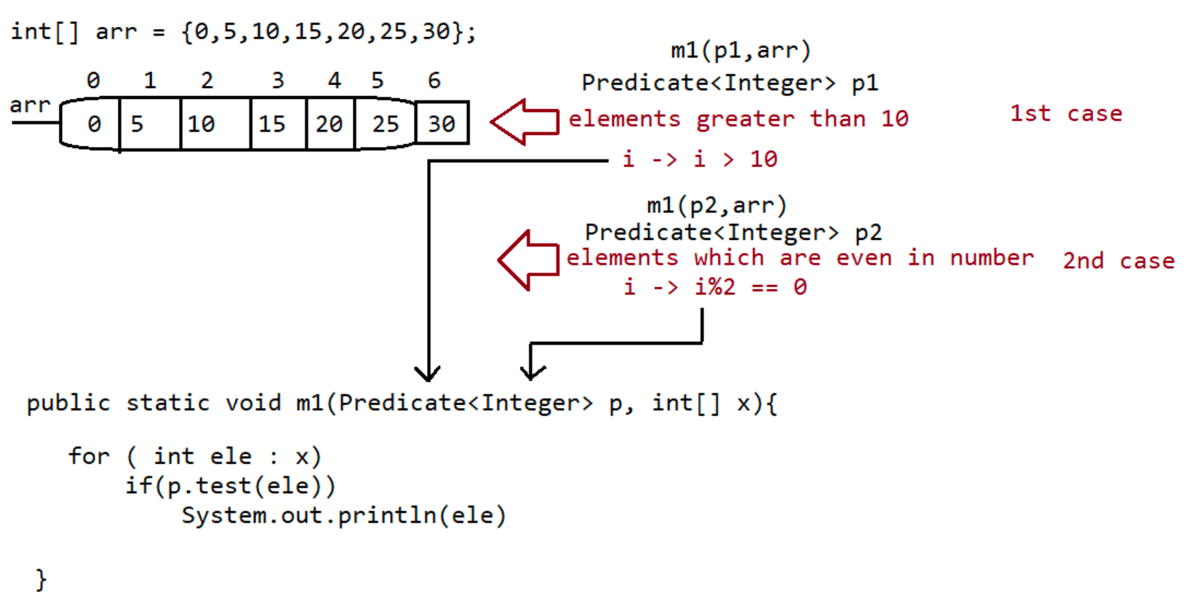

075 Stream API in Java
class Sample
{
private String s;
Sample(String s){
this.s = s;
System.out.println("Constructor executed...."+s);
}
}
@FunctionalInterface
interface Interf
{
public Sample get(String s);
}
public class Test {
public static void main(String[] args){
Interf i = s -> new Sample(s);
i.get("from lambda expression...");
System.out.println();
//constructor reference
Interf i1 = Sample::new;
i1.get("from constructor reference....");
}
}
Example of Method reference
========================
@FunctionalInterface
interface Interf
{
public void m1(int i);
}
public class Test {
//logic coded by other developer
public void m2(int i){
System.out.println(i*i);
System.out.println("logic coming from method reference...");
}
m1)
public static void main(String[] args){
Interf i = x-> System.out.println(x);
i.m1(10);
System.out.println();
//method reference(binding the body of m2() to abstract method
Interf i1 = new Test()::m2;
i1.m1(20);
}
}
Eg:To demonstrate the usage of forEach() to print the elements of Arraylist
==============================================================
import java.util.*;
import java.util.function.*;// public void forEach(java.util.function.Consumer<? super E>);
// public abstract void accept(T t)
class MyConsumer implements Consumer<String>
{
@Override
public void accept(String name){
System.out.println("accept method got called...");
System.out.println(name);
}
}
public class Test {
public static void main(String[] args){
ArrayList<String> names = new ArrayList<String>();
names.add("sachin");
names.add("dhoni");
names.add("kohli");
names.add("dravid");
//Traditional approach
Consumer<String> consumer = new MyConsumer();
names.forEach(consumer);
System.out.println();
//lambda expression
names.forEach(name->System.out.println(name));
System.out.println();
//method reference
names.forEach(System.out::println);
}
}
Stream API
=========
Stream -----> Channel through which there is a free flow movement of data.
Streams
To process objects of the collection, in 1.8 version Streams concept introduced.
What is the differences between Java.util.streams and Java.io streams?
java.util streams meant for processing objects from the collection. Ie, it
represents a stream of objects from the collection
but Java.io streams meant for processing binary and character data with respect to
file.
i.e it represents stream of binary data or character data from the file .
hence Java.io streams and Java.util streams both are different.
What is the difference between collection and stream?
=> If we want to represent a group of individual objects as a single entity then
We should go for collection.
=> If we want to process a group of objects from the collection then we should go
for streams.
=> We can create a stream object to the collection by using stream() method of
Collection interface. stream()
method is a default method added to the Collection in 1.8 version.import java.util.*;
import java.util.stream.*;
public class Test {
public static void main(String[] args){
ArrayList<Integer> al = new ArrayList<Integer>();
al.add(0);
al.add(5);
al.add(10);
al.add(15);
al.add(20);
al.add(25);
System.out.println(al);//[0,5,10,15,20,25]
//till jdk1.7v
ArrayList<Integer> evenList = new ArrayList<Integer>();
for ( Integer i1: al )
if (i1%2==0)
evenList.add(i1);
System.out.println(evenList);//[0,10,20]
//From JDK1.8V we use Streams
//1. Configuration ===> al.stream()
//2. Processing ===> filter(i->i
%2==0).collect(Collectors.toList())
List<Integer> streamList=al.stream().filter(i->i
%2==0).collect(Collectors.toList());
System.out.println(streamList);
streamList.forEach(System.out :: println);
}
}
eg#2.
import java.util.*;
import java.util.stream.*;
public class Test {
public static void main(String[] args){
ArrayList<Integer> al = new ArrayList<Integer>();
al.add(0);
al.add(5);
al.add(10);
al.add(15);
al.add(20);
al.add(25);
System.out.println(al);
// till JDK1.7V
ArrayList<Integer> doubleList = new ArrayList<Integer>();
for ( Integer i1: al )
doubleList.add(i1*2);
System.out.println(doubleList);
// from JDK1.8V
// map-> for every object, if a new object has to be created thengo for Map
List<Integer> streamList = al.stream().map(obj-
>obj*2).collect(Collectors.toList());
System.out.println(streamList);
streamList.forEach(i-> System.out.println(i));
System.out.println();
streamList.forEach(System.out::println);
}
}
=> Stream is an interface present in java.util.stream. Once we got the stream, by
using that we can process objects of that collection.
We can process the objects in the following 2 phases
1.Configuration
2.Processing
1) Configuration:
We can configure either by using filter mechanism or by using map mechanism.
Filtering:
We can configure a filter to filter elements from the collection based on
some boolean condition by using
filter()method of Stream interface.
public Stream filter(Predicate<T> t)
here (Predicate<T > t ) can be a boolean valued function/lambda
expression
Ex:
Stream s = c.stream();
Stream s1 = s.filter(i -> i%2==0);
Hence to filter elements of collection based on some Boolean condition we should go
for filter() method.
Mapping:
If we want to create a separate new object, for every object present in the
collection based on our requirement then we should go for
map() method of Stream interface.
public Stream map (Function f);
It can be lambda expression also
Ex:
Stream s = c.stream();
Stream s1 = s.map(i-> i+10);
Once we performed configuration we can process objects by using several methods.
2) Processing
processing by collect() method
Processing by count()method
Processing by sorted()method
Processing by min() and max() methods
forEach() method
toArray() method
Stream.of()method
eg#1.
import java.util.*;
import java.util.stream.*;
public class Test {
public static void main(String[] args){ArrayList<String>names = new ArrayList<String>();
names.add("sachin");
names.add("saurav");
names.add("dhoni");
names.add("dravid");
names.add("kohli");
names.add("raina");
System.out.println(names);
List<String> reslut = names.stream().filter(name-
>name.length()>5).collect(Collectors.toList());
System.out.println(reslut.size());
long count= names.stream().filter(name->name.length()>5).count();
System.out.println("The no of objects whose string length > 5
is ::"+count);
}
}
import java.util.*;
import java.util.stream.*;
//Comparable(Predefined API for natural sorting order) -> compareTo(Object obj)
//Comparator(for userdefined class for customized sorting order)->
compare(Obj1,Obj2)
public class Test {
public static void main(String[] args){
ArrayList<Integer> al =new ArrayList<Integer>();
al.add(10);
al.add(0);
al.add(15);
al.add(5);
al.add(20);
System.out.println("Before sorting :: "+al);
//using stream api
List<Integer> resultList=
al.stream().sorted().collect(Collectors.toList());
System.out.println("After sorting :: "+resultList);
List<Integer> customizedResult = al.stream().sorted((i1,i2)-
>i2.compareTo(i1)).collect(Collectors.toList());
System.out.println("After sorting :: "+customizedResult);
}
}
import java.util.*;
import java.util.stream.*;
//Comparable(Predefined API for natural sorting order) -> compareTo(Object obj)
//Comparator(for userdefined class for customized sorting order)->
compare(Obj1,Obj2)
public class Test {public static void main(String[] args){
ArrayList<Integer> al =new ArrayList<Integer>();
al.add(10);
al.add(0);
al.add(15);
al.add(5);
al.add(20);
System.out.println("Array List is ::"+al);
Object[] objArr = al.stream().toArray();
for(Object obj: objArr)
System.out.println(obj);
System.out.println();
Integer[] objArr1 = al.stream().toArray(Integer[]::new);
for(Integer obj1: objArr1)
System.out.println(obj1);
}
}
eg
import java.util.*;
import java.util.stream.*;
public class Test {
public static void main(String[] args){
//Stream API ===> Collections(group of objects)
Stream s= Stream.of(9,99,999,9999,99999);
s.forEach(System.out::println);
System.out.println();
Double[] d = {10.0,10.1,10.2,10.3,10.4};
Stream s1= Stream.of(d);
s1.forEach(System.out::println);
}
}
collect()
=======
This method collects the elements from the stream and adding to the specified to
the collection indicated (specified) by argument.
eg#1.
import java.util.*;
import java.util.stream.*;
public class Test {
public static void main(String[] args) {
ArrayList<String> names = new ArrayList<String>();
names.add("sachin");
names.add("saurav");
names.add("dhoni");names.add("yuvi");
System.out.println(names);//[sachin,saurav,dhoni,yuvi]
//Predicate(I)
// public abstract boolean test(T);
List<String> result=names.stream().filter(name->name.length()>5).
collect(Collectors.toList());
System.out.println(result);
//Function(I)<T,R>
// public abstract R apply(T);
List<String> mapResult = names.stream().map(name->
name.toUpperCase()).
collect(Collectors.toList());
System.out.println(mapResult);
}
}
count()
======
This method returns number of elements present in the stream.
public long count()
import java.util.*;
import java.util.stream.*;
public class Test {
public static void main(String[] args) {
ArrayList<String> names = new ArrayList<String>();
names.add("sachin");
names.add("saurav");
names.add("dhoni");
names.add("yuvi");
System.out.println(names);//[sachin,saurav,dhoni,yuvi]
long count = names.stream().filter(name-
>name.length()>5).count();
System.out.println(count);
}
}
III.Processing by sorted()method
If we sort the elements present inside stream then we should go for sorted()
method.
The sorting can either default natural sorting order or customized sorting
order specified by comparator.
sorted()- default natural sorting order
sorted(Comparator c)-customized sorting order.import java.util.*;
import java.util.stream.*;
public class Test {
public static void main(String[] args) {
ArrayList<Integer> al = new ArrayList<Integer>();
al.add(10);
al.add(20);
al.add(0);
al.add(5);
al.add(25);
al.add(15);
System.out.println(al);
List<Integer> result =
al.stream().sorted().collect(Collectors.toList());
System.out.println(result);
List<Integer> customizedResult=al.stream().sorted((i1,i2) ->-
i1.compareTo(i2)).collect(Collectors.toList());
System.out.println(customizedResult);
}
}
IV.Processing by min() and max() methods
min(Comparator c)
max(Comparator c)
returns minimum value according to specified comparator.
returns maximum value according to specified comparator.
import java.util.*;
import java.util.stream.*;
public class Test {
public static void main(String[] args) {
ArrayList<Integer> al = new ArrayList<Integer>();
al.add(10);
al.add(20);
al.add(0);
al.add(5);
al.add(25);
al.add(15);
System.out.println(al);
Integer minValue = al.stream().min((i1,i2)->
i1.compareTo(i2)).get();
System.out.println(minValue);
Integer maxValue = al.stream().max((i1,i2)->
i1.compareTo(i2)).get();
System.out.println(maxValue);
}
}
V.forEach() method
This method will not return anything.
This method will take lambda expression as argument and apply that lambdaexpression for each element present in the stream.
import java.util.*;
import java.util.stream.*;
public class Test {
public static void main(String[] args) {
ArrayList<String>names = new ArrayList<String>();
names.add("AAA");
names.add("BBB");
names.add("CCC");
names.add("DDD");
names.stream().forEach(name -> System.out.println(name));
names.stream().forEach(System.out::println);
}
}
VI.
toArray() method
We can use toArray() method to copy elements present in the stream into specified
array
import java.util.*;
import java.util.stream.*;
public class Test {
public static void main(String[] args) {
ArrayList<Integer> al =new ArrayList<Integer>();
al.add(0);
al.add(10);
al.add(5);
al.add(20);
al.add(15);
System.out.println(al);
Integer[] array = al.stream().toArray(Integer[]::new);
for (Integer element : array)
System.out.println(element);
}
}
VII.Stream.of()method
We can also apply a stream for group of values and for arrays.
Ex:
Stream s=Stream.of(99,999,9999,99999);
s.forEach(System.out:: println);
Double[] d={10.0,10.1,10.2,10.3};
Stream s1=Stream.of(d);
s1.forEach(System.out :: println);

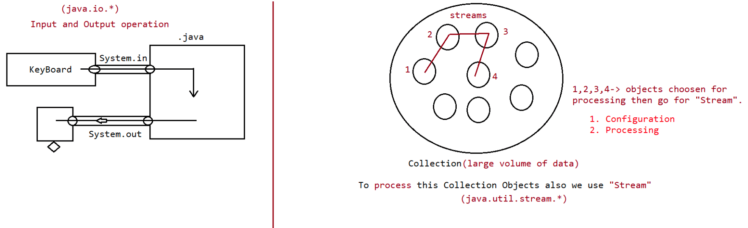

076 File operation in Java (IO)
What is persistency?
It is a mechanism of storing the data permanently on to the file.
In java persistency can be achieved through an API's available inside package
called "java.io".
Input and Output Operations
========================
Agenda:
1. File
2. FileWriter
3. FileReader
4. BufferedWriter
5. BufferedReader
File:
File f=new File("abc.txt");
This line 1st checks whether abc.txt file is already available (or) not if it is
already available then "f" simply refers that file.
If it is not already available then it won't create any physical file just
creates a java File object represents name of the file.
Example:
import java.io.*;
class FileDemo{
public static void main(String[] args)throws IOException{
File f=new File("cricket.txt");
System.out.println(f.exists());//false
f.createNewFile();
System.out.println(f.exists());//true
}
}
1st run
=======
false
true
2nd run
======
true
true
=> A java File object can represent a directory also.
Example:
import java.io.File;
import java.io.IOException;
class FileDemo{
public static void main(String[] args)throws IOException{
File f=new File("IPLTeams");
System.out.println(f.exists());//false
f.mkdir();//Creates a new directory
System.out.println(f.exists());//true
}}
1st run
=======
false
true
2nd run
======
true
true
Note: In UNIX everything is a file, java "file IO" is based on UNIX operating
system
hence in java also we can represent both files and directories by File
object only.
File class constructors
==================
1. File f=new File(String name);
=> Creates a java File object that represents name of the file or directory in
current working directory.
eg#1. File f=new File("abc.txt");
2. File f=new File(String subdirname,String name);
=> Creates a File object that represents name of the file or directory present
in specified sub directory.
eg#1. File f1=new File("abc");
f1.mkdir();
File f2=new File("abc","demo.txt");
3. File f=new File(File subdir,String name);
eg#1.File f1=new File("abc");
f1.mkdir();
File f2=new File(f1,"demo.txt");
Requirement
===========
cwd
=> Write code to create a file named with demo.txt in current working directory.
|=> abc.txt
Program:
import java.io.*;
class FileDemo{
public static void main(String[] args)throws IOException{
File f=new File("demo.txt");
f.createNewFile();
}
}
Requirement
=> Write code to create a directory named with IPLTeam in current working directory
and create a file named with abc.txt in that directory.
cwd
|=> IPLTeam
|=> abc.txt
Program:
import java.io.*;
class FileDemo{public static void main(String[] args)throws IOException{
File f1=new File("IPLTeam");
f1.mkdir();
File f2=new File("IPLTeam","abc.txt");
f2.createNewFile();
}
}
folder.
Requirement: Write code to create a file named with rcb.txt present in c:\IPLTeam
C
|=> IplTeam
|-> rcb.txt
Program:
import java.io.*;
class FileDemo{
public static void main(String[] args)throws IOException{
File f=new File("c:\\IPLTeam","rcb.txt");
f.createNewFile();
}
}
Assuming C:\\IPLTeam should be already available otherwise it would result in
"FileNotFoundException".
Important methods of file class:
1. boolean exists();
Returns true if the physical file or directory available.
2. boolean createNewFile();
This method 1st checks whether the physical file is already available or not
if it is already available then this method simply returns
false without creating any physical file.
If this file is not already available then it will create a new file and
returns true
3. boolean mkdir();
This method 1st checks whether the directory is already available or not if
it is already available then this method simply returns
false without creating any directory.
If this directory is not already available then it will create a new
directory and returns true
4. boolean isFile();
Returns true if the File object represents a physical file.
5. boolean isDirectory();
Returns true if the File object represents a directory.
6. String[] list();
directory.
It returns the names of all files and subdirectories present in the specified
7. long length();
Returns the no of characters present in the file.
8. boolean delete();
To delete a file or directoryRequirement:
Requirement: Write a program to display the names of all files and directories
present in D:\\Java Job Guarantee Batch
Requirement: Write a program to display only file names.
Requirement: Write a program to display only directory names.
import java.io.*;
class Test
{
{
public static void main(String[] args)throws Exception
int dirCount = 0;
int jpgFileCount = 0;
int txtFileCount = 0;
int zipFileCount = 0;
String location = "D:\\Java Job Guarantee Batch";
File f= new File(location);
String[] names = f.list();
for(String name : names){
// D:\\Java Job Guarantee Batch
// all files we are iterating
File f1 = new File(f,name);
if (f1.isDirectory())
dirCount++;
if(f1.isFile()){
if (name.endsWith(".png"))
jpgFileCount++;
if(name.endsWith(".txt"))
txtFileCount++;
if(name.endsWith(".zip"))
zipFileCount++;
}
System.out.println(name);
}
System.out.println("Total no of JPGfiles is :: "+jpgFileCount);
System.out.println("Total no of txtfiles is :: "+txtFileCount);
System.out.println("Total no of Zipfiles is :: "+zipFileCount);
System.out.println("Total no of Directory is :: "+dirCount);
}
//JVM shutdown now
}
FileWriter:
By using FileWriter object we can write character data to the file.
Constructors:
FileWriter fw=new FileWriter(String name);
FileWriter fw=new FileWriter(File f);
The above 2 constructors meant for overriding the data to the file.Instead of overriding if we want append operation then we should go for the
following 2 constructors.
FileWriter fw=new FileWriter(String name,boolean append);
FileWriter fw=new FileWriter(File f,boolean append);
If the specified physical file is not already available then these constructors
will create that file.
Methods:
1. write(int ch);
To write a single character to the file.
2. write(char[] ch);
To write an array of characters to the file.
3. write(String s);
To write a String to the file.
4. flush();
To give the guarantee the total data include last character also written to
the file.
5. close();
To close the stream.
eg#1.
import java.io.FileWriter;
import java.io.IOException;
public class TestApp {
public static void main(String[] args)throws IOException {
FileWriter fw=new FileWriter("abc.txt");
fw.write(73);
fw.write("neuron\nTechnology\nPrivate\nLimited");
fw.write("\n");
char ch[] ={'a','b','c'};
fw.write(ch);
fw.flush();
fw.close();
}
}
A new file will be created automatically
abc.txt
=======
Ineuron
Technology
Private
Limited
abc
Note:
=> The main problem with FileWriter is we have to insert line separator
manually,which is difficult to the programmer. ('\n')
=> And even line separator varing from system to system.
FileReader:
=> By using FileReader object we can read character data from the file.
Constructors:
FileReader fr=new FileReader(String name);FileReader fr=new FileReader (File f);
Methods
=======
1. int read();
value. If
It attempts to read next character from the file and return its Unicode
the next character is not available then we will get -1.
2. int i=fr.read();
3. System.out.println((char)i);
As this method returns unicodevalue , while printing we have to perform type
casting.
4. int read(char[] ch);
It attempts to read enough characters from the file into char[] array and
returns
the no of characters copied from the file into char[] array.
5. File f=new File("abc.txt");
6. Char[] ch=new Char[(int)f.length()];
7. void close();
eg#1.
import java.io.FileReader;
import java.io.IOException;
public class TestApp {
public static void main(String[] args)throws IOException {
FileReader fr=new FileReader("abc.txt");
int i=fr.read();
while(i!=-1){
System.out.println((char)i);
i=fr.read();
}
}

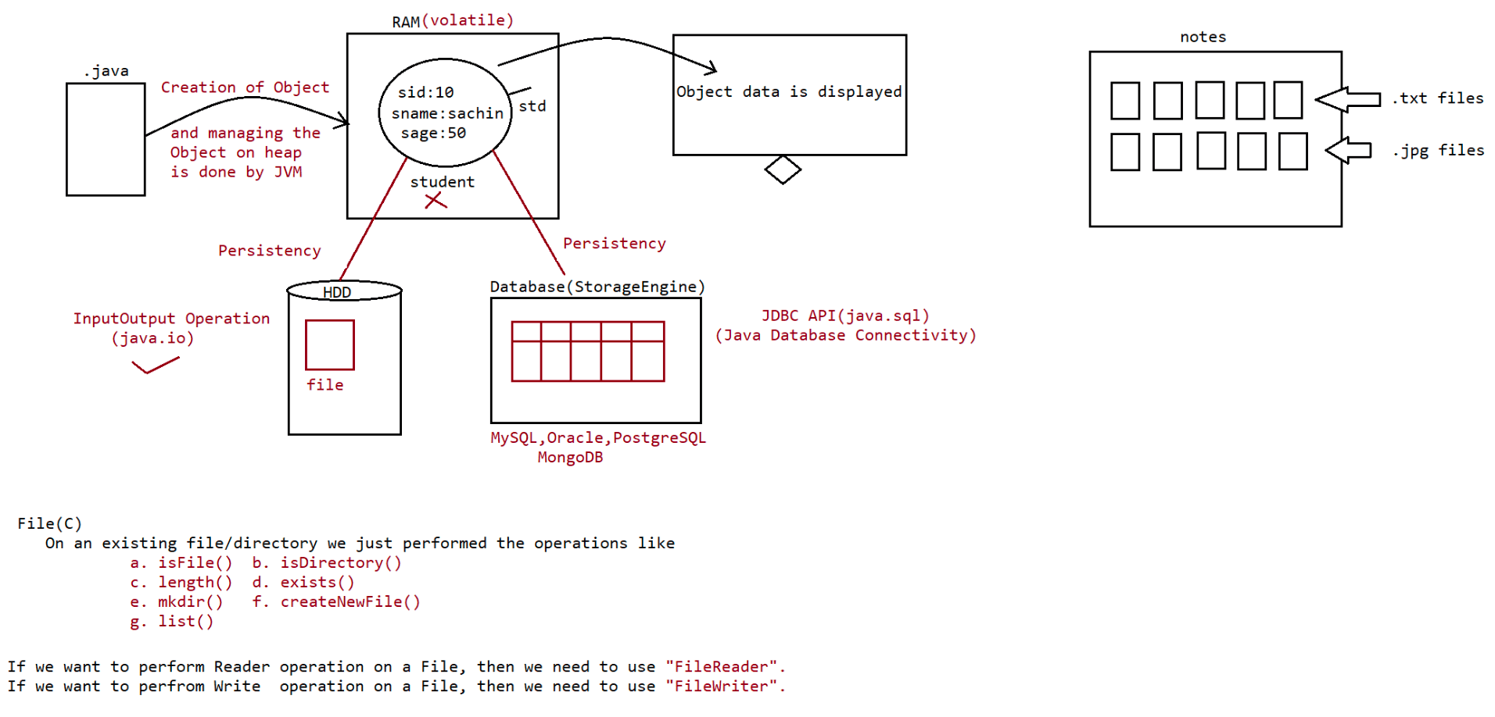

077 File Operation
eg#2. Reading an array of characters
abc.txt
=======
1000 characters are available
Scenario1:
FileReader fr=new FileReader("abc.txt");
char[] ch=new char[10];
int noOfCharactersCopied=fr.read(ch);
Scenario2:
FileReader fr=new FileReader("abc.txt");
char[] ch=new char[10000];
int noOfCharactersCopied=fr.read(ch);
import java.io.FileReader;
import java.io.IOException;
import java.io.File;
public class TestApp {
public static void main(String[] args)throws IOException {
File f=new File("abc.txt");
FileReader fr=new FileReader(f);
char ch[] = new char[(int)f.length()];
fr.read(ch);
String data=new String(ch);
System.out.println(data);
fr.close();
}
}
Usage of FileWriter and FileReader is not recommended because of following reason
1. While writing data by FileWriter compulsory we should insert line separator(\n)
manually which is a bigger headache to the
programmer.
2. While reading data by FileReader we have to read character by character instead
of line by line which is not convenient to the
programmer.
Assume we need to search for a 10 digit mobile no present in a file called
"mobile.txt"
=>Since we can read only character just to search one mobile no 10 searching and
to search 10,000 mobile no we need to read 1cr times,
so performance is very low.
3. To overcome these limitations we should go for BufferedWriter and BufferedReader
concepts.
BufferedWriter:By using BufferedWriter we can write the character data to the file.
It can't communicate with the file directly, it can communicate only with
writer Object.
Constructor
BufferedWriter bw=new BufferedWriter(Writer w);
BufferedWriter bw=new BufferedWriter(Writer w,int buffersize);
Which of the following declarations are valid?
1. BufferedWriter bw=new BufferedWriter("cricket.txt"); //invalid
2. BufferedWriter bw=new BufferedWriter (new File("cricket.txt"));//invalid
3. BufferedWriter bw=new BufferedWriter (new FileWriter("cricket.txt")); //valid
4. BufferedWriter bw=new BufferedWriter(new BufferedWriter(new
FileWriter("crickter.txt")));//valid
// it indicates 2 levels of buffering.
Methods
========
1. write(int ch);
2. write(char[] ch);
3. write(String s);
4. flush();
5. close();
6. newline();
Inserting a new line character to the file.
Note:
When compared with FileWriter which of the following capability(facility) is
available as method in BufferedWriter.
1. Writing data to the file.
2. Closing the writer.
3. Flush the writer.
4. Inserting newline character.(newLine())
Ans. 4
eg#1.
import java.io.*;
/*
public void newLine() throws java.io.IOException;
*/
class Test
{
public static void main(String[] args)throws Exception
{
FileWriter fw = new FileWriter("abc.txt",true);
BufferedWriter bw = new BufferedWriter(fw);
bw.write(105);
bw.write("Neuron");
bw.newLine();
char[] ch ={'P','W','S','K','I','L','L','S'};
bw.write(ch);
bw.newLine();
bw.write("unicorn");bw.flush();//to make sure the operation is succesfull on file
bw.close();//internally fw.close() call will happen
}
//JVM shutdown now
}
Note
1.bw.close()// recomended to use
2.fw.close()// not recomended to use
3.bw.close()// not recomended to use
fw.close()
=> When ever we are closing BufferedWriter automatically underlying writer will be
closed and we are not close explicitly.
BufferedReader:
Constructors:
This is the most enhanced(better) Reader to read character data from the file.
BufferedReader br=new BufferedReader(Reader r);
BufferedReader br=new BufferedReader(Reader r,int buffersize);
Note
=> BufferedReader can not communicate directly with the File it should communicate
via some Reader object.
=> The main advantage of BufferedReader over FileReader is we can read data line
by line instead of character by character.
Methods:
1. int read();
2. int read(char[] ch);
3. String readLine();
It attempts to read next line and return it , from the File. if the next
line is not available then this method returns null.
4. void close();
eg#1.Read the data from the file called "abc.txt"4
/*
public java.lang.String readLine() throws java.io.IOException;
*/
import java.io.*;
public class TestApp {
public static void main(String[] args)throws IOException {
FileReader fr=new FileReader("abc.txt");
BufferedReader br=new BufferedReader(fr);
String line= br.readLine();
while(line!=null){
System.out.println(line);
line=br.readLine();
}
br.close();
}
}Note:
1.br.close() // recomended to use
2.fw.close() // not recomended to use
3.br.close() // not recomended to use both
fw.close()
=> Whenever we are closing BufferedReader automatically underlying FileReader will
be closed it is not required to close explicitly.
=> Even this rule is applicable for BufferedWriter also.
PrintWriter:
=> This is the most enhanced Writer to write text data to the file.
=> By using FileWriter and BufferedWriter we can write only character data to the
File but by using PrintWriter
we can write any type of data to the File.
Constructors:
PrintWriter pw=new PrintWriter(String name);
PrintWriter pw=new PrintWriter(File f);
PrintWriter pw=new PrintWriter(Writer w);
PrintWriter can communicate either directly to the File or via some Writer object
also.
Methods:
1. write(int ch);
2. write (char[] ch);
3. write(String s);
4. flush();
5. close();
6. print(char ch);
7. print (int i);
8. print (double d);
9. print (boolean b);
10.print (String s);
11.println(char ch);
12.println (int i);
13.println(double d);
14.println(boolean b);
15.println(String s);
eg#1.
import java.io.*;
/*
public void print(xxxx type);
public void println(xxxx type);
*/
class Test
{
{
public static void main(String[] args)throws Exception
FileWriter fw = new FileWriter("abc.txt");
PrintWriter out = new PrintWriter(fw);
out.write(100);//100 unicode value will be written to a fileout.println(100);//100 only will be written to the file
out.println(true);
out.println('c');
out.println("DenisRitchie");
out.flush();
out.close();
}
out.write('\n');
//JVM shutdown now
}
What is the difference between write(100) and print(100)?
=> In the case of write(100) the corresponding character "d" will be added to the
File but
=> In the case of print(100) "100" value will be added directly to the File.
Note 1:
1. The most enhanced Reader to read character data from the File is BufferedReader.
2. The most enhanced Writer to write character data to the File is PrintWriter.
Note 2:
1.In general we can use Readers and Writers to handle character data. Where as we
can use InputStreams and OutputStreams to handle
binary data(like images, audio files, video files etc).
2. We can use OutputStream to write binary data to the File and we can use
InputStream to read binary data from the File
Character Data => Reader and Writer
Binary Data => InputStream and OutputStream
Requirement => file1.txt ,file2.txt copy all the contents to file3.txt
import java.io.*;
class Test
{
public static void main(String[] args)throws Exception
{
PrintWriter pw = new PrintWriter("file3.txt");
//reading from first file and writing to file3.txt
BufferedReader br= new BufferedReader(new FileReader("file1.txt"));
String line = br.readLine();
while (line!=null)
{
pw.println(line);
line=br.readLine();
}
//reading from second file and writing to file3.txt
br =new BufferedReader(new FileReader("file2.txt"));
line = br.readLine();
while (line!=null)
{
pw.println(line);
line=br.readLine();}
//To write all the data to file3.txt
pw.flush();
br.close();
pw.close();
System.out.println("Open file3.txt to see the result");
}
//JVM shutdown now
}
Requirement => file1.txt file2.txt copy one line from file1.txt and from file2.txt
to file3.txt.
import java.io.*;
class Test
{
{
public static void main(String[] args)throws Exception
PrintWriter pw = new PrintWriter("file3.txt");
//reading from first file and writing to file3.txt
BufferedReader br1= new BufferedReader(new FileReader("file1.txt"));
String line1 = br1.readLine();
BufferedReader br2 =new BufferedReader(new FileReader("file2.txt"));
String line2 = br2.readLine();
while (line1!=null || line2!=null)
{
if (line1!=null)
{
pw.println(line1);
line1=br1.readLine();
}
{
if(line2!=null)
pw.println(line2);
line2=br2.readLine();
}
}
//To write all the data to file3.txt
pw.flush();
br1.close();
br2.close();
pw.close();
System.out.println("Open file3.txt to see the result");
}
//JVM shutdown now
}Requirement => Write a program to remove duplicates from the file
import java.io.*;
class Test
{
{
public static void main(String[] args)throws Exception
BufferedReader br = new BufferedReader(new FileReader("input.txt"));
PrintWriter pw = new PrintWriter("output.txt");
String target = br.readLine();
while (target!=null)
{
boolean isAvailable =false;
BufferedReader br1 =new BufferedReader(new
FileReader("output.txt"));
String line = br1.readLine();
break
//control comes out of while looop in smooth fashion without
while (line!=null)
{
//if matched control should come out with break
if (line.equals(target))
{
isAvailable = true;
break;
}
line=br1.readLine();
}
if (isAvailable==false){
pw.println(target);
pw.flush();
}
target = br.readLine();
}
br.close();
pw.close();
}
//JVM shutdown now
}
Requirement => Write a program to perform extraction of mobile no only if there is
no duplicates
import java.io.*;
class Test
{
{
public static void main(String[] args)throws Exception
BufferedReader br = new BufferedReader(new FileReader("input.txt"));PrintWriter pw = new PrintWriter("output.txt");
String target = br.readLine();
while (target!=null)
{
boolean isAvailable =false;
BufferedReader br1 =new BufferedReader(new
FileReader("delete.txt"));
String line = br1.readLine();
//control comes out of while looop in smooth fashion without
break
while (line!=null)
{
//if matched control should come out with break
if (line.equals(target))
{
isAvailable = true;
break;
}
line=br1.readLine();
}
if (isAvailable==false){
pw.println(target);
pw.flush();
}
br.close();
pw.close();
}
}
target = br.readLine();
//JVM shutdown now
}
Write a code to read the data from the file and identify which data is of larger in
length(assuming the data is String)
import java.io.*;
class Test
{
public static void main(String[] args)throws Exception
{
BufferedReader br = new BufferedReader(new FileReader("data.txt"));
String data = br.readLine();
int maxLength = 0;
String result = "";
while (data!=null)
{
int resultLength=data.length();
if (maxLength<resultLength)
{
maxLength = resultLength;
result=data;
}"+result);
}
data= br.readLine();
}
System.out.println("The maxLength string data in a file is ::
System.out.println("The maxLength string in a file is :: "+maxLength);
//JVM shutdown now
}

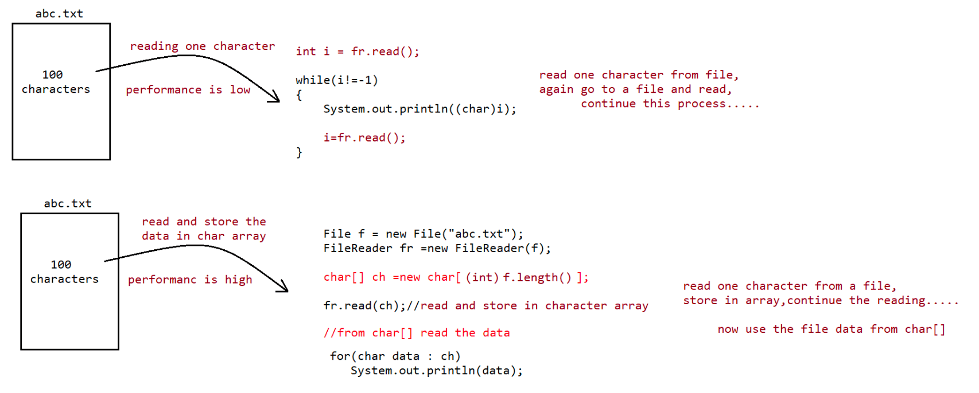
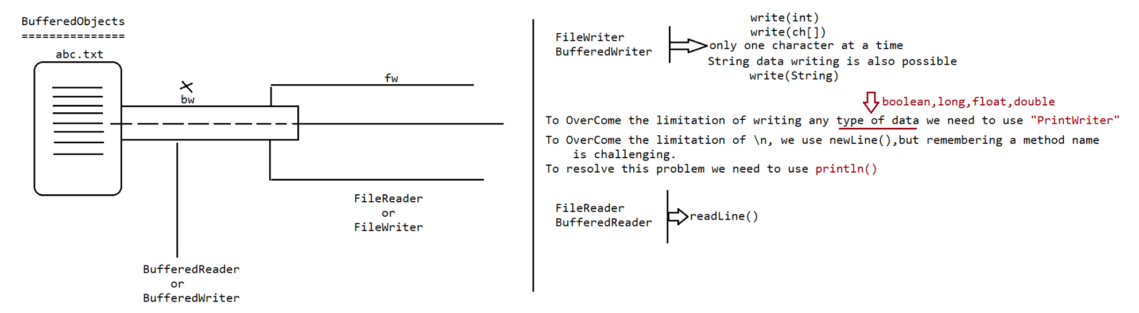
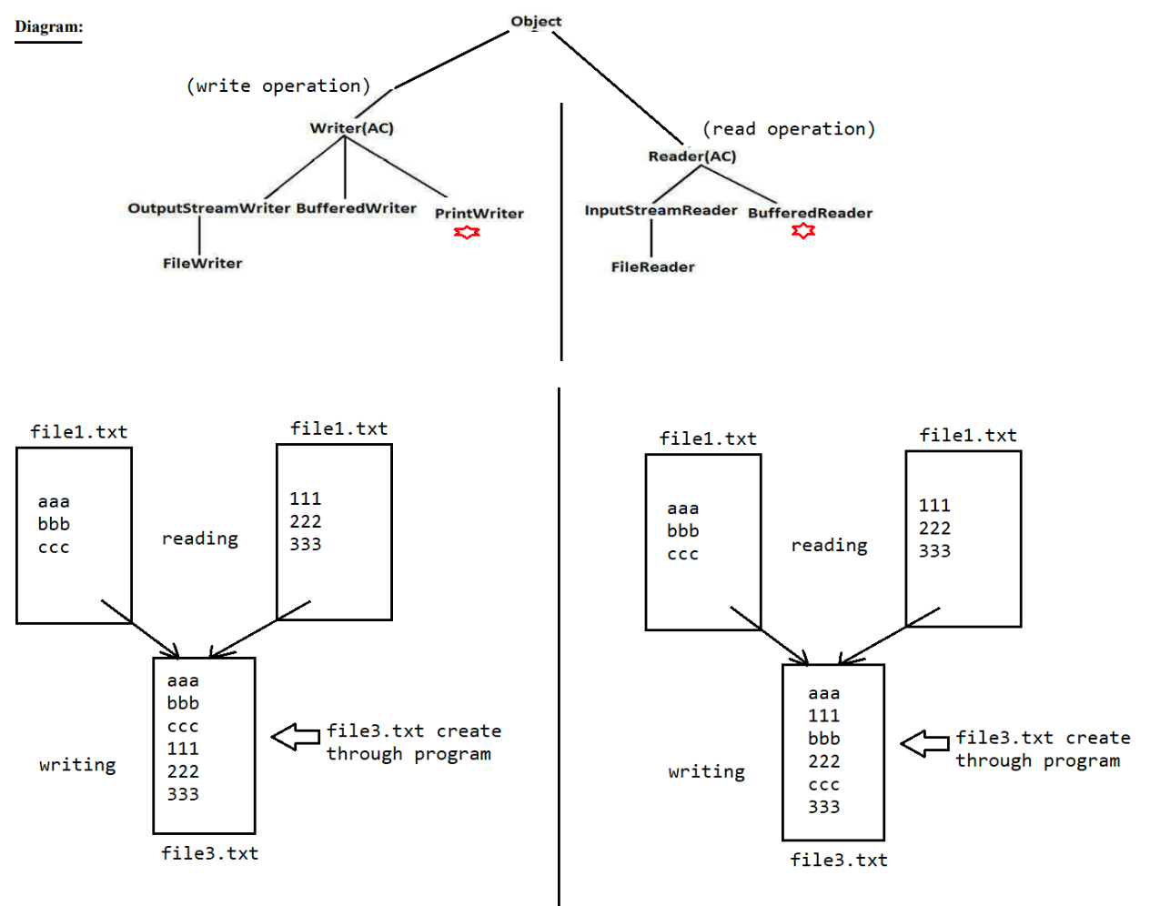

079 Serialization and DeSerialization
Agenda :
1. Serialization
2. Deserialization
3. transient keyword
4. static Vs transient
5. transient Vs final
6. Object graph in serialization.
7. customized serialization.
8. Serialization with respect inheritance.
9. Externalization
10. Difference between Serialization & Externalization
11. SerialVersionUID
Serialization
=> The process of saving (or) writing state of an object to a file is called
serialization but strictly speaking it is the process of
converting an object from java supported form to either network supported
form (or) file supported form.
=> By using FileOutputStream and ObjectOutputStream classes we can achieve
serialization process.
|=> writeObject(Object obj)
De-Serialization
=> The process of reading state of an object from a file is called DeSerialization
but strictly speaking it is the process of
converting an object from file supported form (or) network supported form to
java supported form.
=> By using FileInputStream and ObjectInputStream classes we can achieve
DeSerialization.
|=> readObject()
import java.io.*;
/*
public java.io.ObjectOutputStream(java.io.OutputStream) throws
java.io.IOException;
public java.io.FileOutputStream(java.lang.String) throws
java.io.FileNotFoundException;
public final void writeObject(java.lang.Object) throws java.io.IOException;
public java.io.ObjectInputStream(java.io.InputStream) throws java.io.IOException;
public java.io.FileInputStream(java.lang.String) throws
java.io.FileNotFoundException;
public final java.lang.Object readObject() throws java.io.IOException,
java.lang.ClassNotFoundException;
*/
{
class Dog implements Serializable
static{
}
Dog(){
}
int i = 10;
int j = 20;
System.out.println("static block gets executed...");
System.out.println("Object is created...");
}class Test
{
{
public static void main(String[] args)throws Exception
Dog d = new Dog();
System.out.println("Serialization started.....");
String fileName = "abc.ser";
FileOutputStream fos = new FileOutputStream(fileName);
ObjectOutputStream oos = new ObjectOutputStream(fos);
oos.writeObject(d);
System.out.println("Serialized Object refernce is ::"+d);
System.out.println("Serialization ended.....");
//To pause the execution till we press some key from keyboard
System.in.read();
System.out.println("De-Serialization started.....");
FileInputStream fis = new FileInputStream("abc.ser");
ObjectInputStream ois = new ObjectInputStream(fis);
Object obj=ois.readObject();
Dog d1 = (Dog)obj;
System.out.println("De-Serialized Object refernce is ::"+d1);
System.out.println("De-Serialization ended.....");
}
//JVM shutdown now
}
eg#2.
import java.io.FileOutputStream;
import java.io.IOException;
import java.io.ObjectOutputStream;
import java.io.FileInputStream;
import java.io.ObjectInputStream;
import java.io.Serializable;
class Dog implements Serializable{
int i=10;
int j=20;
}
class Cat implements Serializable{
int i=100;
int j=200;
}
public class TestApp {
public static void main(String[] args)throws
IOException,ClassNotFoundException {
Dog d1=new Dog();
Cat c1=new Cat();
System.out.println("serialization started");
FileOutputStream fos= new FileOutputStream("abc.ser");
ObjectOutputStream oos=new ObjectOutputStream(fos);
oos.writeObject(d1);
oos.writeObject(c1);System.out.println("Serialization ended");
System.out.println("Deserialization started");
FileInputStream fis=new FileInputStream("abc.ser");
ObjectInputStream ois=new ObjectInputStream(fis);
Dog d2=(Dog) ois.readObject();
Cat c2=(Cat) ois.readObject();
System.out.println("Deserialization ended");
System.out.println("Dog object data");
System.out.println(d2.i+"\t" +d2.j);
System.out.println("Cat object data");
System.out.println(c2.i+"\t" +c2.j);
}
}
Output
serialization started
Serialization ended
Deserialization started
Deserialization ended
Dog object data
10 20
Cat object data
100 200
Note:
1. We can perform Serialization only for Serilizable objects.
2. An object is said to be Serilizable if and only if the corresponding class
implements Serializable interface.
3. Serializable interface present in java.io package and does not contain any
abstract methods. It is marker interface.
The required ability will be provided automatically by JVM.
4. We can add any no. Of objects to the file and we can read all those objects from
the file but in which order we wrote
objects in the same order only the objects will come back. That is order is
important.
5. If we are trying to serialize a non-serializable object then we will get
RuntimeException saying "NotSerializableException".
Transient keyword:
1. transient is the modifier applicable only for variables,but not for classes and
methods.
2. While performing serialization if we don't want to save the value of a
particular variable to meet security constant such
type of variable ,then we should declare that variable with "transient"
keyword.
3. At the time of serialization JVM ignores the original value of transient
variable and save default value to the file .
4. That is transient means "not to serialize".
eg#1.
import java.io.FileOutputStream;
import java.io.IOException;
import java.io.ObjectOutputStream;
import java.io.FileInputStream;import java.io.ObjectInputStream;
import java.io.Serializable;
class Dog implements Serializable{
int i=10;
transient int j=20;
}
public class TestApp {
public static void main(String[] args)throws
IOException,ClassNotFoundException {
Dog d1=new Dog();
System.out.println("serialization started");
FileOutputStream fos= new FileOutputStream("abc.ser");
ObjectOutputStream oos=new ObjectOutputStream(fos);
oos.writeObject(d1);
System.out.println("Serialization ended");
System.out.println("Deserialization started");
FileInputStream fis=new FileInputStream("abc.ser");
ObjectInputStream ois=new ObjectInputStream(fis);
Dog d2=(Dog) ois.readObject();
System.out.println("Deserialization ended");
System.out.println("Dog object data");
System.out.println(d2.i+"\t" +d2.j);
}
}
Output
serialization started
Serialization ended
Deserialization started
Deserialization ended
Dog object data
10 0
static Vs transient :
1. static variable is not part of object state hence they won't participate in
serialization because of this declaring a static variable as
transient there is no use.
import java.io.FileOutputStream;
import java.io.IOException;
import java.io.ObjectOutputStream;
import java.io.FileInputStream;
import java.io.ObjectInputStream;
import java.io.Serializable;
class Dog implements Serializable{
static transient int i=10;
int j=20;
}
public class TestApp {public static void main(String[] args)throws
IOException,ClassNotFoundException {
Dog d1=new Dog();
System.out.println("serialization started");
FileOutputStream fos= new FileOutputStream("abc.ser");
ObjectOutputStream oos=new ObjectOutputStream(fos);
oos.writeObject(d1);
System.out.println("Serialization ended");
System.out.println("Deserialization started");
FileInputStream fis=new FileInputStream("abc.ser");
ObjectInputStream ois=new ObjectInputStream(fis);
Dog d2=(Dog) ois.readObject();
System.out.println("Deserialization ended");
System.out.println("Dog object data");
System.out.println(d2.i+"\t" +d2.j);
}
}
Output
serialization started
Serialization ended
Deserialization started
Deserialization ended
Dog object data
10 20
Transient Vs Final:
1. final variables will be participated into serialization directly by their
values.
Hence declaring a final variable as transient there is no use.
//the compiler assign the value to final variable
eg: final int x= 10;
int y = 20;
becoz x is final.
System.out.println(y);
System.out.println(x);// compiler will replace this as System.out.println(20)
import java.io.FileOutputStream;
import java.io.IOException;
import java.io.ObjectOutputStream;
import java.io.FileInputStream;
import java.io.ObjectInputStream;
import java.io.Serializable;
class Dog implements Serializable{
int i=10;
transient final int j=20;
}
public class TestApp {
public static void main(String[] args)throwsIOException,ClassNotFoundException {
Dog d1=new Dog();
System.out.println("serialization started");
FileOutputStream fos= new FileOutputStream("abc.ser");
ObjectOutputStream oos=new ObjectOutputStream(fos);
oos.writeObject(d1);
System.out.println("Serialization ended");
System.out.println("Deserialization started");
FileInputStream fis=new FileInputStream("abc.ser");
ObjectInputStream ois=new ObjectInputStream(fis);
Dog d2=(Dog) ois.readObject();
System.out.println("Deserialization ended");
System.out.println("Dog object data");
System.out.println(d2.i+"\t" +d2.j);
}
}
Output
Serialization started
Serialization ended
Deserialization started
Deserialization ended
Dog object data
10 20
Declaration output
================
1.
int i=10;
int j=20;
output
10 -------- 20
2.
transient int i=10;
int j=20;
output
0-------20
3.
transient int i=10;
transient static int j=20;
output
0---------20
4.
transient final int i=10;
transient int j=20;output
10-------0
5.
transient final int i=10;
transient static int j=20;
output
10--------20
Note:
We can serialize any no of objects to the file but in which order we serialized in
the same order only we have to deserialize,
if we change the order then it would result in "ClassCastException".
Example :
Dog d1=new Dog( );
Cat c1=new Cat( );
Rat r1=new Rat( );
FileOutputStreamfos=new FileOutputStream("abc.ser");
ObjectOutputStreamoos=new ObjectOutputStream(fos);
oos.writeObject(d1);
oos.writeObject(c1);
oos.writeObject(r1);
FileInputStreamfis=new FileInputStream("abc.ser");
ObjectInputStreamois=new ObjectInputStream(fis);
Dog d2=(Dog)ois.readObject();
Cat c2=(Cat)ois.readObject();
Rat r2=(Rat)ois.readObject();
=> If we don't know the order of Serialization then we need to use the following
code
FileInputStream fis =new FileInputStream("abc.ser");
ObjectInputStream ois=new ObjectInputStream(fis);
Object obj=ois.readObject();
if(obj instanceof Dog){
Dog d=(Dog)obj;
//perform operation related to Dog
}
if(obj instanceof Cat){
Cat C=(Cat)obj;
//perform operation related to Cat
}
if(obj instanceof Rat){
Rat r=(Rat)obj;
//perform operation related to Rat
}
Object graph in serialization:
1. Whenever we are serializing an object the set of all objects which are reachable
from that object will be serialized
automatically. This group of objects is nothing but object graph in
serialization.
2. In object graph every object should be Serializable otherwise we will get
runtime exception saying
"NotSerializableException".eg#1.
import java.io.Serializable;
import java.io.FileOutputStream;
import java.io.ObjectOutputStream;
import java.io.FileInputStream;
import java.io.ObjectInputStream;
import java.io.IOException;
class Dog implements Serializable{
Cat c=new Cat();
}
class Cat implements Serializable{
Rat r=new Rat();
}
class Rat implements Serializable{
int i=10;
}
public class Test {
public static void main(String[] args)throws
IOException,ClassNotFoundException{
Dog d= new Dog();
System.out.println("Serialization Started");
FileOutputStream fos= new FileOutputStream("abc.ser");
ObjectOutputStream oos=new ObjectOutputStream(fos);
oos.writeObject(d);
System.out.println("Serialization ended");
System.out.println("***********************************");
System.out.println("DeSerialization Started");
FileInputStream fis= new FileInputStream("abc.ser");
ObjectInputStream ois=new ObjectInputStream(fis);
Dog d1=(Dog)ois.readObject();
System.out.println(d1.c.r.i);
System.out.println("DeSerialization ended");
}
}
Output
======
Serialization Started
Serialization ended
***********************************
DeSerialization Started
10
DeSerialization ended
CustomizedSerialization
=======================
During default Serialization there may be a chance of lose of information due to
transient keyword.example: remember mango and money inside it.
eg#1.
import java.io.Serializable;
import java.io.FileOutputStream;
import java.io.ObjectOutputStream;
import java.io.FileInputStream;
import java.io.ObjectInputStream;
import java.io.IOException;
class Account implements Serializable{
String name="sachin";
transient String password="tendulkar";
}
public class Test {
public static void main(String[] args)throws
IOException,ClassNotFoundException{
Account acc=new Account();
System.out.println(acc.name +"=====> "+ acc.password);
System.out.println("Serialization Started");
FileOutputStream fos= new FileOutputStream("abc.ser");
ObjectOutputStream oos=new ObjectOutputStream(fos);
oos.writeObject(acc);
System.out.println("Serialization ended");
System.out.println("***********************************");
System.out.println("DeSerialization Started");
FileInputStream fis= new FileInputStream("abc.ser");
ObjectInputStream ois=new ObjectInputStream(fis);
acc=(Account)ois.readObject();
System.out.println(acc.name +"=====> "+ acc.password);
System.out.println("DeSerialization ended");
}
}
=> In the above example before serialization Account object can provide proper
username and password.
But after Deserialization Account object can provide only username but not
password. This is due to declaring password as transient.
Hence doing default serialization there may be a chance of loss of information
due to transient keyword.
=> We can recover this loss of information by using customized serialization.
We can implements customized serialization by using the following two methods.
1. private void writeObject(ObjectOutputStream os) throws Exception.
=> This method will be executed automatically by jvm at the time of
serialization.
=> Hence at the time of serialization if we want to perform any extra work we
have to define that in this
method only. (prepare encrypted password and write encrypted password
seperate to the file )
2. private void readObject(ObjectInputStream is) throws Exception.
=> This method will be executed automatically by JVM at the time of
Deserialization.
Hence at the time of Deserialization if we want to perform any extra activitywe have to define that in this method only.
(read encrypted password , perform decryption and assign decrypted password
to the current object password variable )
eg#1.
import java.io.Serializable;
import java.io.FileOutputStream;
import java.io.ObjectOutputStream;
import java.io.FileInputStream;
import java.io.ObjectInputStream;
import java.io.IOException;
class Account implements Serializable{
String name="sachin";
transient String password="tendulkar";
private void writeObject(ObjectOutputStream oos)throws Exception{
oos.defaultWriteObject();//performing default Serialization
String epwd="123"+password;//performing encryption
oos.writeObject(epwd);//write the encrypted data to file(abc.ser)
}
private void readObject(ObjectInputStream ois)throws Exception{
ois.defaultReadObject();//performing default Serialization
String epwd=(String)ois.readObject();//performing decryption
password=epwd.substring(3);//writing the extra data to Object
}
}
public class Test {
public static void main(String[] args)throws
IOException,ClassNotFoundException{
Account acc=new Account();
System.out.println(acc.name +"=====> "+ acc.password);
System.out.println("Serialization Started");
FileOutputStream fos= new FileOutputStream("abc.ser");
ObjectOutputStream oos=new ObjectOutputStream(fos);
oos.writeObject(acc);
System.out.println("Serialization ended");
System.out.println("***********************************");
System.out.println("DeSerialization Started");
FileInputStream fis= new FileInputStream("abc.ser");
ObjectInputStream ois=new ObjectInputStream(fis);
acc=(Account)ois.readObject();
System.out.println(acc.name +"=====> "+ acc.password);
System.out.println("DeSerialization ended");
}
}
=> At the time of Account object serialization JVM will check is there any
writeObject() method in Account class or not.=> If it is not available then JVM is responsible to perform serialization(default
serialization).
=> If Account class contains writeObject() method then JVM feels very happy and
executes that Account class
writeObject() method.
=> The same rule is applicable for readObject() method also.
import java.io.*;
/*
public java.io.ObjectOutputStream(java.io.OutputStream) throws
java.io.IOException;
public java.io.FileOutputStream(java.lang.String) throws
java.io.FileNotFoundException;
public final void writeObject(java.lang.Object) throws java.io.IOException;
public java.io.ObjectInputStream(java.io.InputStream) throws java.io.IOException;
public java.io.FileInputStream(java.lang.String) throws
java.io.FileNotFoundException;
public final java.lang.Object readObject() throws java.io.IOException,
java.lang.ClassNotFoundException;
*/
{
class Account implements Serializable
String userName = "sachin";
transient String password = "tendulkar";//loss of information
transient int pin=4444;//loss of information
//Write a logic of Serialization
private void writeObject(ObjectOutputStream oos) throws Exception{
System.out.println("writeObject method is called....");
// perform default serialization
oos.defaultWriteObject();
// perform encryption on password
String encypwd = "123" + password;// 123tendulkar
int encypin = 1111 + pin;// 5555
// write the encrytped data as object to serialized file
oos.writeObject(encypwd);
oos.writeInt(encypin);
}
//Write a logic of Deserialization
private void readObject(ObjectInputStream ois) throws Exception{
System.out.println("readObject method is called....");
//perform default deserialization
ois.defaultReadObject();
//read encrypted data from serialized file
String encypwd = (String)ois.readObject();
int encypin = ois.readInt();// perform decryption and attach it to instance variable
password = encypwd.substring(3);// tendulkar
pin = encypin - 1111;// 4444
}
}
{
class Test
{
public static void main(String[] args)throws Exception
Account account =new Account();
System.out.println("Serialization started.....");
String fileName = "abc.ser";
FileOutputStream fos = new FileOutputStream(fileName);
ObjectOutputStream oos = new ObjectOutputStream(fos);
oos.writeObject(account);
System.out.println("Serialization ended.....");
//To pause the execution till we press some key from keyboard
System.in.read();
System.out.println("De-Serialization started.....");
FileInputStream fis = new FileInputStream("abc.ser");
ObjectInputStream ois = new ObjectInputStream(fis);
Account acc=(Account)ois.readObject();
System.out.println("Username is :: "+acc.userName);
System.out.println("Password is :: "+acc.password);
System.out.println("Pin is :: "+acc.pin);
System.out.println("De-Serialization ended.....");
}
//JVM shutdown now
}
Output
D:\IOOperations>javac Test.java
D:\IOOperations>java Test
Serialization started.....
writeObject method is called....
Serialization ended.....
De-Serialization started.....
readObject method is called....
Username is :: sachin
Password is :: tendulkar
Pin is :: 4444
De-Serialization ended.....

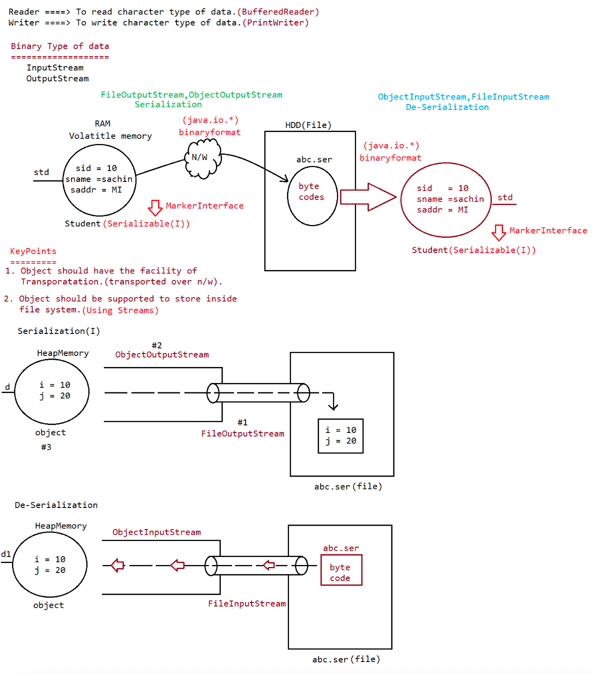
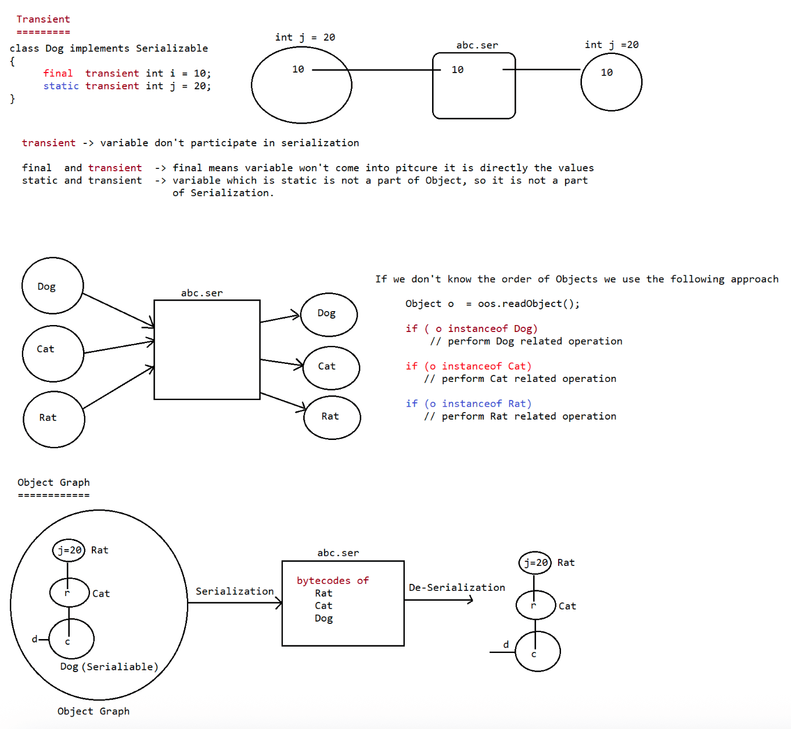
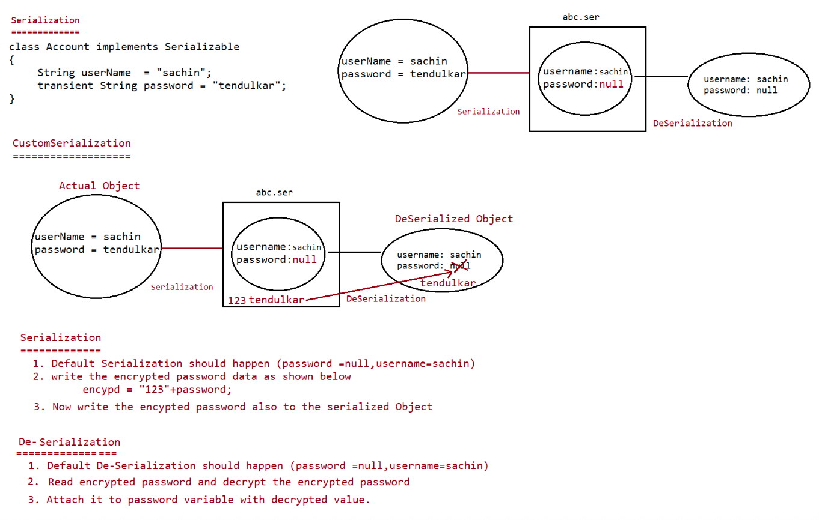

Collections(c)

==============

=> It is a utility class present in java.util package.

=> It defines the method meant for sorting,searching and reversing the elements

Note:

Collection(I)

|=> List

a. It wont speak about sorting,so use Collections(c).

|=> Set

a. It we want sorting then we can opt for TreeSet.

|=> Queue

a. If we want sorting then we can opt for PriorityQueue.

To sort the elemets of List

===========================

1. public static void sort(List l)

1.It sorts the element in ascending order/alphabetical order

2.The elements should be homogenous and it should comparable otherwise it leads to

ClassCastException.

3.If it contains null,it would result in "NullPointerException".

2. public static void sort(List l,Comparator c)

1. It sorts the elements based on our customization.

Sorting based on NaturalSorting order

====================================

import java.util.Collections;

import java.util.ArrayList;

public class TestApp{

public static void main(String... args){

ArrayList l=new ArrayList();

l.add("Z");

l.add("A");

l.add("K");

l.add("N");

l.add(null);//RE:ClassCastException

l.add(new Integer(10));//RE:NullPointerException

System.out.println("Before Sorting: "+l);//[Z,A,K,N]

Collections.sort(l);

System.out.println("After Sorting: "+l);//[A,K,N,Z]

}

}

Sorting based on CustomizedSorting order

=======================================

eg#1.

import java.util.Collections;

import java.util.ArrayList;

import java.util.Comparator;

public class TestApp{

public static void main(String... args){

ArrayList l=new ArrayList();

l.add("Z");

l.add("A");

l.add("K");

l.add("N");

System.out.println("Before Sorting: "+l);//[Z,A,K,N]

Collections.sort(l,new MyComparator());

System.out.println("After Sorting: "+l);//[Z,N,K,A]

}

}

class MyComparator implements Comparator{

@Override

public int compare(Object obj1,Object obj2){

String s1=obj1.toString();

String s2=obj2.toString();

return s2.compareTo(s1);

}

}

Searching Elements of List:

1) public static int binarySearch(List l, Object target);

If we are Sorting List According to Natural Sorting Order then we have to Use this Method.

2) public static int binarySearch(List l, Object target, Comparator c);

If we are Sorting List according to Comparator then we have to Use this Method.

Conclusions:

=> Internally the Above Search Methods will Use Binary Search Algorithm.

=> Before performing Search Operation Compulsory List should be Sorted. Otherwise we will

get Unpredictable Results.

=> Successful Search Returns Index.

=> Unsuccessful Search Returns Insertion Point.

=> Insertion Point is the Location where we can Insert the Target Element in the SortedList.

=> If the List is Sorted according to Comparator then at the Time of Search Operation Also we

should Pass the Same Comparator Object. Otherwise we will get Unpredictable Results.

Program: To Search Elements of List According to Natural Sorting Order

import java.util.*;

class CollectionsSearchDemo {

public static void main(String args[]) {

ArrayList al = new ArrayList();

al.add("Z");

al.add("A");

al.add("M");

al.add("K");

al.add("a");

System.out.println(al); //[Z, A, M, K, a]

Collections.sort(al);

System.out.println(al); //[A, K, M, Z, a]

System.out.println(Collections.binarySearch(al, "Z")); //3

System.out.println(Collections.binarySearch(al, "J")); //-2

}

}

Program: To Search Elements of List According to Customized Sorting Order

import java.util.*;

class CollectionsSearchDemo {

public static void main(String args[]) {

ArrayList al = new ArrayList();

al.add(15);

al.add(0);

al.add(20);

al.add(10);

al.add(5);

System.out.println(al); //[15, 0, 20, 10, 5]

Collections.sort(al, new MyComparator());

System.out.println(al); //[20, 15, 10, 5, 0]

System.out.println(Collections.binarySearch(al, 10, new MyComparator())); //2

System.out.println(Collections.binarySearch(al, 13, new MyComparator())); //-3

System.out.println(Collections.binarySearch(al, 17)); //-6

}

}

class MyComparator implements Comparator {

public int compare(Object obj1, Object obj2) {

Integer I1 = (Integer)obj1;

Integer I2 = (Integer)obj2;

return I2.compareTo(I1);

}

}

Eg: For the List of 3 Elements

A B Z

1) Range of Successful Search: 0 To 2

2) Range of Unsuccessful Search: -4 To -1

3) Total Result Range: -4 To 2

Note: For the List of n Elements

1) Successful Result Range: 0 To n-1

2) Unsuccessful Result Range: -(n+1) To -1

3) Total Result Range: -(n+1) To n-1

Reversing the Elements of List:

public static void reverse(List l);

import java.util.*;

class CollectionsReverseDemo {

public static void main(String args[]) {

ArrayList al = new ArrayList();

al.add(15);

al.add(0);

al.add(20);

al.add(10);

al.add(5);

System.out.println(al); //[15, 0, 20, 10, 5]

Collections.reverse(al);

System.out.println(al); //[5,10,20,0,15]

}

}

reverse() VsreverseOrder():

=> We can Use reverse() to Reverse Order of Elements of List.

=> We can Use reverseOrder() to get Reversed Comparator.

Comparator c1 = Collecctions.reverseOrder(Comparator c);

| |

Descending Order Ascending Order

Arrays

======

=> Arrays Class is an Utility Class to Define Several Utility Methods for Array Objects.

Sorting Elements of Array:

1) public static void sort(primitive[] p); To Sort According to Natural Sorting Order.

2) public static void sort(Object[] o); To Sort According to Natural Sorting Order.

3) public static void sort(Object[] o, Comparator c);To Sort According to Customized Sorting

Order.

Note:

=> For Object Type Arrays we can Sort According to Natural Sorting Order OR Customized Sorting Order.

=> But we can Sort primitive[] Only Based on Natural Sorting.

import java.util.*;

class ArraysSortDemo {

public static void main(String args[]) {

int[] a = {10, 5, 20, 11, 6};

System.out.println("Primitive Array Before Sorting:");

for (int a1 : a) {

System.out.println(a1);

}

Arrays.sort(a);

System.out.println("Primitive Array After Sorting:");

for (int a1 : a) {

System.out.println(a1);

}

String[] s = {"A", "Z", "B"};

System.out.println("Object Array Before Sorting:");

for (String s1 : s) {

System.out.println(s1);

}

Arrays.sort(s);

System.out.println("Object Array After Sorting:");

for (String s1 : s) {

System.out.println(s1);

}

Arrays.sort(s,new MyComparator());

System.out.println("Object Array After Sorting by Comparator:");

for (String s1 : s) {

System.out.println(s1);

}

}

}

class MyCompoarator implements Comparator{

public int compare(Object obj1,Object obj2){

String s1=obj1.toString();

String s2=(String)obj2;

return s2.compareTo(s1);

}

}

Output

Primitive Array Before Sorting:

10

5

20

11

6

Primitive Array After Sorting:

5

6

10

11

20

Object Array Before Sorting:

A

Z

B

Object Array After Sorting:

A

B

Z

Object Array After Sorting By Comparator:

Z

B

Z

Searching the Elements of Array

===============================

1) public static int binarySearch(primitive[] p, primitive target);

If the Primitive Array Sorted According to Natural Sorting Order then we have to Use this

Method.

2) public static int binarySearch(Object[] a, Object target);

If the Object Array Sorted According to Natural Sorting Order then we have to Use this

Method.

3) public static intbinarySearch(Object[] a, Object target, Comparator c);

If the Object Array Sorted According to Comparator then we have to Use this Method.

Note: All Rules of Array Class binarySearch() are Exactly Same as Collections Class

binarySearch().

Program: To Search Elements of Array

import java.util.Arrays;

import java.util.Comparator;

//import static java.util.Arrays.*;

class ArraysSearchDemo {

public static void main(String args[]) {

int[] a = {10, 5, 20, 11, 6};

Arrays.sort(a); //Sort By Natural Order

System.out.println(Arrays.binarySearch(a, 6)); //1

System.out.println(Arrays.binarySearch(a, 14)); //-5

String[] s = {"A", "Z", "B"};

Arrays.sort(s);

System.out.println(binarySearch(s, "Z")); //2

System.out.println(binarySearch(s, "S")); //-3

Arrays.sort(s, new MyComparator());

System.out.println(binarySearch(s, "Z", new MyComparator())); //0

System.out.println(binarySearch(s, "S", new MyComparator())); //-2

System.out.println(binarySearch(s, "N")); //-4

}

}

class MyComparator implements Comparator {

public int compare(Object obj1, Object obj2) {

String s1 = obj1.toString();

String s2 = obj2.toString();

return s2.compareTo(s1);

}

}

Conversion of Array to List

===========================

Note: To convert the Collection to Array we have a method called

Object[] toArray()

=> Arrays Class contains asList() for this

public static List asList(Object[] a);

=> Strictly Speaking this Method won't Create an Independent List Object, Just we are

Viewing existing Array in List Form.

=> By using Array Reference if we Perform any Change Automatically that Change will be

reflected to List Reference.

=> Similarly by using List Reference if we Perform any Change Automatically that Change will

be reflected to Array.

=> By using List Reference if we are trying to Perform any Operation which Varies the Size

then we will get Runtime Exception Saying UnsuportedOperationException.

eg:

String s[]={"A","B","Z"};

List l = Arrays.asList(s);

l.add("K");//RE: UnsuportedOperationException

l.remove(1);//RE: UnsuportedOperationException

l.set(1, "K"); //valid

=> By using List Reference if we are trying to Replace with Heterogeneous Objects then we will

get Runtime Exception Saying ArrayStoreException.

Program: To View Array in List Form

import java.util.*;

class ArraysAsListDemo {

public static void main(String args[]) {

String[] s = {"A", "Z", "B"};

List l = Arrays.asList(s);

System.out.println(l); //[A, Z, B]

s[0] = "K";

System.out.println(l); //[K, Z, B]

l.set(1, "L");

for (String s1 : s )

System.out.println(s1); //K L B

l.add("sachin"); //RE: java.lang.UnsupportedOperationException

l.remove(2); //RE: java.lang.UnsupportedOperationException

l.set(1, new Integer[10]); //RE: java.lang.ArrayStoreException:[Ljava.lang.Integer;

}

}

1st pgm

========

ts.add(10);

ts.add(0);

ts.add(15);

ts.add(5);

ts.add(20);

ts.add(20);

2nd pgm

========

ts.add(new StringBuffer("A"));

ts.add(new StringBuffer("Z"));

ts.add(new StringBuffer("K"));

ts.add(new StringBuffer("L"));

3rd pgm

=======

Write a java program to insert the String and StringBuffer object into TreeSet where sorting order

is in increasing length order.if 2 objects have same length then consider their

Alphabetical order

sample::

ts.add(new StringBuffer("A"));

ts.add(new StringBuffer("ABC"));

ts.add(new StringBuffer("AA"));

ts.add("XX");

ts.add("ABCE");

ts.add("A");

ConcurrentCollections

=====================

Objective

1. Majority of the Collection classes are not Threadsafety due to which there is a possiblity

of "DataIncosistency" problem, so these collection classes are not ThreadSafe.

2. Already existing ThreadSafe Collection classes are

a. Vector

b. Hashtable

c. synchronizedList(),synchronizedSet(),synchronizedMap() of Collections class performance

not upto the mark because it increases the waiting time for other threads even if

they want to just do read operation.

import java.util.ArrayList;

import java.util.Iterator;

public class Test {

public static void main(String[] args) {

ArrayList al = new ArrayList();

al.add("A");

al.add("B");

al.add("C");

Iterator itr = al.iterator();

while (itr.hasNext()){

String s = (String)itr.next();

System.out.println(s);

al.add("D");//java.util.ConcurrentModificationException

}

}

}

3. In Normal Collections,Simultaneoulsy if one Thread is performing read operation ,other thread can't perform write operation if we try to do it would result in "ConccurentModificatinException"

So normal Collections are not suitable for "MultiThreading Applications".

eg#1.

import java.util.ArrayList;

import java.util.Iterator;

public class Test extends Thread{

static ArrayList<String> l=new ArrayList<String>();

@Override

public void run(){

try

{

Thread.sleep(2000);

}

catch (InterruptedException ie)

{

ie.printStackTrace();

}

System.out.println("Child Thread updating list");

l.add("B");

}

public static void main(String[] args) throws InterruptedException{

l.add("A");

l.add("B");

l.add("C");

Test t=new Test();

t.start();

Iterator itr=l.iterator();

while(itr.hasNext()){

String data=(String)itr.next();

System.out.println("Main Thread iterating list and the object is : "+data);

Thread.sleep(3000);

}

System.out.println(l);

}

}

Output

Main Thread iterating list and the object is : A

Child Thread updating list

RE: java.util.ConcurrentModification.

To resolve the above mentioned problems SUNMS introduced a new concpet in 1.5v called "ConcurrentCollections".

KeyPoints of ConcurrentCollections

==================================

1) Concurrent Collections are Always Thread Safe.

2) When compared with Traditional Thread Safe Collections Performance is More because of

different Locking Mechanism(segment locking/bucket locking mechanism).

3) While One Thread interacting Collection the Other Threads are allowed to Modify

Collection in Safe Manner(best suited on Scalable Threading Application).

Note: ConcurrentCollections -> Special package java.util.concurrent.*;

Most important ConcurrentCollections

====================================

1.ConcurrentHashMap

2.CopyonWriteArrayList

3.CopyonWriteArraySet

ConcurrentHashMap

=================

Map(I)

|extends

ConcurrentMap(I)

|

|implements

|

ConcurrentHashMap(C)

Normal map => put(Object obj)

|=> If the key already present, then it will update the value for the

corresponding key and old value will be returns.

ConcurrentMap => putIfAbsent(Object obj)

|=> If the key is already present,then it will not update

the key with new value.

eg#1.

importjava.util.concurrent.ConcurrentHashMap;

class Test {

public static void main(String[] args) {

ConcurrentHashMap m = new ConcurrentHashMap();

m.put(10, "sachin");

m.put(10, "afridi");

System.out.println(m); //{10=afridi}

m.putIfAbsent(10, "miller");

System.out.println(m); //{10=afridi}

}

}

2.

Normal map => remove(Object obj)

|=> If the key already present, then it will remove that particular

entry from the Map.

ConcurrentMap => remove(Object Key,Object value)

|=> If both key and value matches only then that particular

entry will be removed from the Map.

import java.util.concurrent.ConcurrentHashMap;

public class Test{

public static void main(String[] args) {

ConcurrentHashMap<Integer,String> chm = new ConcurrentHashMap<Integer,String>();

chm.put(10,"sachin");

chm.remove(10,"afridi");

System.out.println(chm);//{10=sachin}

}

}

3.

Normal map => replace(Object key,Object value)

|=> If the key already present, then update a new value.

ConcurrentMap => replace(Object Key,Object value,Object newValue)

|=> If both key and value matches only then update the

new value.

import java.util.concurrent.ConcurrentHashMap;

public class Test{

public static void main(String[] args) {

ConcurrentHashMap<Integer,String> m = new ConcurrentHashMap<Integer,String>();

m.put(10, "sachin");

m.replace(10, "afridi", "miller");

System.out.println(m); //{10=sachin}

m.replace(10, "sachin", "afridi");

System.out.println(m); //{10=afridi}

}

}

ConcurrentHashMap

================

=> Underlying Data Structure is Hashtable.

=> ConcurrentHashMap allows Concurrent Read and Thread Safe Update Operations.

=> To Perform Read Operation Thread won’t require any Lock. But to Perform Update

Operation Thread requires Lock but it is the Lock of Only a Particular Part of Map

(Bucket Level Lock).

=> Instead of Whole Map Concurrent Update achieved by Internally dividing Map into

Smaller Portion which is defined by Concurrency Level.

=> The Default Concurrency Level is 16.

=> That is ConcurrentHashMap Allows simultaneous Read Operation and simultaneously 16

Write (Update) Operations.

=> null is Not Allowed for Both Keys and Values.

=> While One Thread iterating the Other Thread can Perform Update Operation and

ConcurrentHashMap Never throw ConcurrentModificationException.

Constructors:

1) ConcurrentHashMap m = new ConcurrentHashMap();

Creates an Empty ConcurrentHashMap with Default Initial Capacity 16 and Default Fill

Ratio 0.75 and Default Concurrency Level 16.

2) ConcurrentHashMap m = new ConcurrentHashMap(int initialCapacity);

3) ConcurrentHashMap m = new ConcurrentHashMap(int initialCapacity, float fillRatio);

4) ConcurrentHashMap m = new ConcurrentHashMap(int initialCapacity, float fillRatio,

int concurrencyLevel);

5) ConcurrentHashMap m = new ConcurrentHashMap(Map m);

eg#1.

import java.util.concurrent.ConcurrentHashMap;

class Test {

public static void main(String[] args) {

ConcurrentHashMap m = new ConcurrentHashMap();

m.put(101, "A");

m.put(102, "B");

m.putIfAbsent(103, "C");

m.putIfAbsent(101, "D");

m.remove(101, "D");

m.replace(102, "B", "E");

System.out.println(m); //{103=C, 102=E, 101=A}

}

}

eg#1.

import java.util.concurrent.ConcurrentHashMap;

import java.util.*;

class MyThread extends Thread {

//static HashMap m = new HashMap(); // java.util.ConcurrentModificationException

static ConcurrentHashMap m = new ConcurrentHashMap();

@Overrride

public void run() {

try {

Thread.sleep(2000);

}

catch (InterruptedException e) {}

System.out.println("Child Thread updating Map");

m.put(103, "C");

}

public static void main(String[] args) throws InterruptedException {

m.put(101, "A");

m.put(102, "B");

MyThread t = new MyThread();

t.start();

Set s = m.keySet();

Iterator itr = s.iterator();

while (itr.hasNext()) {

Integer I1 = (Integer) itr.next();

S.o.p("Main Thread iterating and Current Entry is:"+I1+"..............."+m.get(I1));

Thread.sleep(3000);

}

System.out.println(m);

}

}

Update and we won’t get any ConcurrentModificationException.

=> If we Replace ConcurrentHashMap with HashMap then we will get ConcurrentModificationException.

Difference b/w HashMap and ConcurrentHashMap

============================================

HashMap => Not Thread Safe

ConcurrentHashMap => Thread Safe

HashMap => Performance is high as Threads are not required to wait to operate.

ConcurrentHashMap => Performance is low as Threads are required to operate.

HashMap => One Thread while Opeating on HashMap,other thread are not allowed to modify

if it tries to do it would result in "ConcurrentModificationException".

ConcurrentHashMap => One Thread while Opeating on HashMap,other thread are allowed to modify

in safe manner, it wont throw "ConcurrentModificationException".

HashMap => Iterator of HashMap if FailFast.

ConcurrentHashMap => Iterator of ConcurrentHashMap is FailSafe.

HashMap => null is allowed for both keys and values.

ConcurrentHashMap => null is not allowed for both keys and values.

HashMap => Introduced in 1.2v

ConcurrentHashMap => Introduced in 1.5v

Difference b/w ConcurrentHashMap,synchronizedMap() and Hashtable

ConcurrentHashMap=>Thread safety without putting lock on entire Object lock at bucket level

synchronizedMap()=>Thread safety by putting lock on entire Object

Hashtable =>Thread safety by putting lock on entire Object

ConcurrentHashMap=>Mulitple Threads are allowed to operate on Object in same manner

synchronizedMap()=>Only One Thread is allowed to operate on Object

Hashtable =>Only One Thread is allowed to operate on Object

ConcurrentHashMap=>Read operation can be performed without any Lock,to perform update/write we

need Object level lock.

synchronizedMap()=>To perform read and update we need Object level lock

Hashtable =>To perform read and update we need Object level lock

ConcurrentHashMap=>No ConcurrentModificationException

synchronizedMap()=>It would result in ConcurrentModificationException

Hashtable =>It would result in ConcurrentModificationException

ConcurrentHashMap=>Iterator is FailSafe

synchronizedMap()=>Iterator is FailFast

Hashtable =>Iterator is FailFast

ConcurrentHashMap=>null not allowed for both keys and values

synchronizedMap()=>null allowed for keys and values

Hashtable =>null not allowed for both keys and values

ConcurrentHashMap=>JDK1.5V

synchronizedMap()=>JDK1.2V

Hashtable =>JDK1.0V

CopyOnWriteArrayList

====================

Collection(I)

|extends

List(I)

|implements

CopyOnWriteArrayList(c)

package :: java.util.concurrent.CopyOnWriteArrayList(c)

=> It is a Thread Safe Version of ArrayList as the Name indicates CopyOnWriteArrayList

Creates a Cloned Copy of Underlying ArrayList for Every Update Operation at Certain

Point Both will Synchronized Automatically Which is taken Care by JVM Internally.

=> As Update Operation will be performed on cloned Copy there is No Effect for the Threads

which performs Read Operation.

=> It is Costly to Use because for every Update Operation a cloned Copy will be Created.

Hence CopyOnWriteArrayList is the Best Choice if Several Read Operations and Less

Number of Write Operations are required to Perform.

=> Insertion Order is Preserved.

=> Duplicate Objects are allowed.

=> Heterogeneous Objects are allowed.

=> null Insertion is Possible.

=> It implements Serializable, Clonable and RandomAccess Interfaces.

=> While One Thread iterating CopyOnWriteArrayList, the Other Threads are allowed to

Modify and we won’t get ConcurrentModificationException. That is iterator is FailSafe.

=> Iterator of ArrayList can Perform Remove Operation but Iterator of CopyOnWriteArrayList can’t Perform Remove Operation. Otherwise we will get RuntimeException Saying UnsupportedOperationException.

Constructors:

1) CopyOnWriteArrayList l = new CopyOnWriteArrayList();

2) CopyOnWriteArrayList l = new CopyOnWriteArrayList(Collection c);

3) CopyOnWriteArrayList l = new CopyOnWriteArrayList(Object[] a);

Methods

boolean addIfAbsent(Object o): The Element will be Added if and Only if List doesn’t

contain this Element.

CopyOnWriteArrayList l = new CopyOnWriteArrayList();

l.add("A");

l.add("A");

l.addIfAbsent("B");

l.addIfAbsent("B");

System.out.println(l); //[A, A, B]

int addAllAbsent(Collection c): The Elements of Collection will be Added to the List if

Elements are Absent and Returns Number of Elements Added.

ArrayList l = new ArrayList();

l.add("A");

l.add("B");

CopyOnWriteArrayList l1 = new CopyOnWriteArrayList();

l1.add("A");

l1.add("C");

System.out.println(l1); //[A, C]

l1.addAll(l);

System.out.println(l1); //[A, C, A, B]

ArrayList l2 = new ArrayList();

l2.add("A");

l2.add("D");

l1.addAllAbsent(l2);

System.out.println(l1); //[A, C, A, B, D]

eg#1.

import java.util.concurrent.CopyOnWriteArrayList;

import java.util.ArrayList;

class Test {

public static void main(String[] args) {

ArrayList l = new ArrayList();

l.add("A");

l.add("B");

CopyOnWriteArrayList l1 = new CopyOnWriteArrayList();

l1.addIfAbsent("A");

l1.addIfAbsent("C");

l1.addAll(l);

ArrayList l2 = new ArrayList();

l2.add("A");

l2.add("E");

l1.addAllAbsent(l2);

System.out.println(l1); //[A, C, A, B, E]

}

}

eg#2.

import java.util.concurrent.CopyOnWriteArrayList;

import java.util.*;

class MyThread extends Thread {

static CopyOnWriteArrayList<String> cowal = new CopyOnWriteArrayList<String>();

@Override

public void run() {

try {

Thread.sleep(2000);

}

catch (InterruptedException e) {}

System.out.println("Child Thread updating Map");

cowal.add("C");

}

public static void main(String[] args) throws InterruptedException {

cowal.add("A");

cowal.add("B");

MyThread t = new MyThread();

t.start();

Iterator itr = cowal.iterator();

while (itr.hasNext()) {

String I1 = (String) itr.next();

System.out.println("Main Thread iterating and Current Object is :: "+I1);

Thread.sleep(3000);

}

System.out.println(cowal);

}

}

=> In the Above Example while Main Thread iterating List Child Thread is allowed to Modify

and we won’t get any ConcurrentModificationException.

=> If we Replace CopyOnWriteArrayList with ArrayList then we will get

ConcurrentModificationException.

eg#2.

import java.util.concurrent.CopyOnWriteArrayList;

import java.util.Iterator;

class Test {

public static void main(String[] args){

CopyOnWriteArrayList l = new CopyOnWriteArrayList();

l.add("A");

l.add("B");

l.add("C");

l.add("D");

System.out.println(l); //[A, B, C, D]

Iterator itr = l.iterator();

while (itr.hasNext()) {

String s = (String)itr.next();

if (s.equals("D"))

itr.remove();//RE: java.lang.UnsupportedOperationException

}

System.out.println(l);

}

}

Iterator of CopyOnWriteArrayList can’t Perform Remove Operation. Otherwise we will get

RuntimeException: UnsupportedOperationException.

eg#3.

import java.util.concurrent.CopyOnWriteArrayList;

import java.util.Iterator;

class Test {

public static void main(String[] args) {

CopyOnWriteArrayList l = new CopyOnWriteArrayList();

l.add("A");

l.add("B");

l.add("C");

Iterator itr = l.iterator();

l.add("D");

while (itr.hasNext()) {

String s = (String)itr.next();

System.out.println(s); //[A,B,C]

}

}

}

=> If We Replace CopyOnWriteArrayList with normal ArrayList it would result in "ConcurrentModificationException".

Differences between ArrayList and CopyOnWriteArrayList

ArrayList => It is Not Thread Safe.

CopyOnWriteArrayList=> It is Not Thread Safe because Every Update

Operation will be performed on Separate

cloned Copy.

ArrayList => While One Thread iterating List Object, the Other Threads are Not allowed to Modify List Otherwise we will get ConcurrentModificationException.

CopyOnWriteArrayList => While One Thread iterating List Object, the Other Threads are allowed to Modify List in Safe Manner and we won’t get ConcurrentModificationException.

ArrayList => Iterator is Fail-Fast.

CopyOnWriteArrayList => Iterator is Fail-Safe.

ArrayList => Iterator of ArrayList can Perform Remove Operation.

CopyOnWriteArrayList => Iterator of CopyOnWriteArrayList can’t

Perform Remove Operation Otherwise we will

get RuntimeException: UnsupportedOperationException.

ArrayList => Introduced in 1.2 Version.

CopyOnWriteArrayList => Introduced in 1.5 Version.

Difference b/w CopyOnWriteArrayList,synchornizedList and Vector

CopyOnWriteArrayList

We will get Thread Safety because Every Update Operation will be performed on Separate cloned Copy.

At a Time Multiple Threads are allowed to Access/ Operate on CopyOnWriteArrayList.

While One Thread iterating List Object, the Other Threads are allowed to Modify Map and we won’t get ConcurrentModificationException.

Iterator is Fail-Safe and won’t raise ConcurrentModificationException.

Iterator can’t Perform Remove Operation Otherwise we will get

UnsupportedOperationException.

Introduced in 1.5 Version.

synchronizedList

We will get Thread Safety because at a Time List can be accessed by Only One Thread at a Time.

At a Time Only One Thread is allowed to Perform any Operation on List Object.

While One Thread iterating , the Other Threads are Not allowed to Modify List. Otherwise we will get ConcurrentModificationException.

Iterator is Fail-Fast and it will raise ConcurrentModificationException.

Iterator canPerform Remove Operation.

Introduced in 1.2 Version.

Vector

We will get Thread Safety because at a Time Only One Thread is allowed to Access Vector Object.

At a Time Only One Thread is allowed to Operate on Vector Object.

While One Thread iterating, the Other Threads are Not allowed to Modify Vector. Otherwise we will get ConcurrentModificationException.

Iterator is Fail-Fast and it will raise ConcurrentModificationException.

Iterator can Perform Remove Operation.

Introduced in 1.0 Version

CopyOnWriteArraySet

==================

Collection (I)

|

Set (I)

|

CopyOnWriteArraySet (C)

=> It is a Thread Safe Version of Set.

=> Internally Implement by CopyOnWriteArrayList.

=> Insertion Order is Preserved.

=> Duplicate Objects are Notallowed.

=> Multiple Threads can Able to Perform Read Operation simultaneously but for Every

Update Operation a Separate cloned Copy will be Created.

=> As for Every Update Operation a Separate cloned Copy will be Created which is Costly

Hence if Multiple Update Operation are required then it is Not recommended to Use

CopyOnWriteArraySet.

=> While One Thread iterating Set the Other Threads are allowed to Modify Set and we won’t

get ConcurrentModificationException.

=> Iterator of CopyOnWriteArraySet can PerformOnly Read Operation and won’t Perform

Remove Operation. Otherwise we will get RuntimeException: UnsupportedOperatonException.

Constructors:

1) CopyOnWriteArraySets = new CopyOnWriteArraySet();

Creates an Empty CopyOnWriteArraySet Object.

2) CopyOnWriteArraySet s = new CopyOnWriteArraySet(Collection c);

Creates CopyOnWriteArraySet Object which is Equivalent to given Collection Object.

Methods:Whatever Methods Present in Collection and Set Interfaces are the Only Methods

Applicable for CopyOnWriteArraySet and there are No Special Methods.

import java.util.concurrent.CopyOnWriteArraySet;

class Test {

public static void main(String[] args) {

CopyOnWriteArraySet s = new CopyOnWriteArraySet();

s.add("A");

s.add("B");

s.add("C");

s.add("A");

s.add(null);

s.add(10);

s.add("D");

System.out.println(s);

}

}

Differences between CopyOnWriteArraySet() and synchronizedSet()

CopyOnWriteArraySet()

=====================

It is Thread Safe because Every Update Operation will be performed on Separate Cloned Copy.

While One Thread iterating Set, the Other Threads are allowed to Modify and we won’t

get ConcurrentModificationException.

Iterator is Fail Safe.

Iterator can Perform Only Read Operation and can’t Perform Remove Operation Otherwise we will get RuntimeException Saying UnsupportedOperationException.

Introduced in 1.5 Version.

synchronizedSet()

=================

It is Thread Safe because at a Time Only One Thread can Perform Operation.

While One Thread iterating, the Other Threads are Not allowed to Modify Set Otherwise we will get

ConcurrentModificationException.

Iterator is Fail Fast.

Iterator can Perform Both Read and Remove Operations.

Introduced in 1.7 Version.

Fail Fast Vs Fail Safe Iterators:

Fail Fast Iterator:While One Thread iterating Collection if Other Thread trying to Perform

any Structural Modification to the underlying Collection then immediately Iterator Fails by

raising ConcurrentModificationExcepion. Such Type of Iterators are Called Fail Fast Iterators.

import java.util.ArrayList;

import java.util.Iterator;

class Test {

public static void main(String[] args) {

ArrayList l = new ArrayList();

l.add("A");

l.add("B");

Iterator itr = l.iterator();//FailFast Iterator

while(itr.hasNext()) {

String s = (String)itr.next();

System.out.println(s); //A

l.add("C"); // java.util.ConcurrentModificationException

}

}

}

Note: Internally Fail Fast Iterator will Use Some Flag named with MOD to Check underlying

Collection is Modified OR Not while iterating.

Fail Safe Iterator:

=> While One Thread iterating if the Other Threads are allowed to Perform any Structural

Changes to the underlying Collection, Such Type of Iterators are Called Fail Safe Iterators.

=> Fail Safe Iterators won’t raise ConcurrentModificationException because Every Update

Operation will be performed on Separate cloned Copy.

import java.util.concurrent.CopyOnWriteArraySet;

import java.util.Iterator;

class Test {

public static void main(String[] args) {

CopyOnWriteArraySet l = new CopyOnWriteArraySet();

l.add("A");

l.add("B");

Iterator itr = l.iterator();//FailSafe Iterator

while(itr.hasNext()) {

String s = (String)itr.next();

System.out.println(s); //A

l.add("C");

}

}

}

refer: failfast and failsafe iterator.png

Generics

========

The purpose of Generics is

1. To provide TypeSafety.

2. To resolve TypeCasting problems.

Case1:

TypeSafety

A guranatee can be provided based on the type of elements.

If our programming requriement is to hold only String type of Objects,we can choose

String Array.

By mistake if we are trying to add any another type of Objects, we will get "CompileTimeError".

eg#1.

String[] s=new String[10000];

s[0] = "dhoni";

s[1] = "sachin";

s[2] = new Integer(10); //CE: incompatible types found : java.lang.Integer

required: java.lang.String

W.r.t Arrays we can give guratante that what type of elements is present inside Array, hence

Arrays are safe to used w.r.t type,so Arrays as TypeSafety.

eg#2.

ArrayList l=new ArrayList();

l.add("dhoni");

l.add("sachin");

l.add(new Integer(10));

...

....

String s1=(String)l.get(0);

String s2=(String)l.get(1);

String s3=(String)l.get(2); //RE: ClassCastException

For Collections, we can't give gurantee for the type of elements present inside Collection.

If our pgm requirement is to hold only String type of Objects then if we choose ArrayList by

mistake if we are trying to add any other type of Object,we won't get any CompileTimeError,but

the program may fail at runtime.

Note: Arrays are TypeSafe,Where as Collections are not TypeSafe.

Arrays provide guarantee for the type of elements we hold, whereas Collections won't provide

gurantee for the type of elements.

Need of Generics

================

1. Arrays to use we need to know the size from the begining,but if we don't the size and still

if we want to provide type casting we need to use "Collections along with Generics".

Case2:

Type casting

============

eg#1.

String s[]=new String[3];

s[0] = "sachin";

String name=s[0];//Typecasting not required as we it holds only String elements only.

eg#2.

ArrayList l=new ArrayList();

l.add("sachin");

String name=l.get(0);//CE: found : java.lang.Object

required: java.lang.String

String name=(String)l.get(0);

|=>TypeCasting is compulsory when we work with Collections.

To Overcome the above mentioned problems of Collections we need to go for Generics in 1.5V, which

provides TypeSafety and to Resolve TypeCasting problems.

How TypeSafety is provided in Generics and how it resolves the problems of TypeCasting?

eg#1.

ArrayList al=new ArrayList();//Non-Generic ArrayList which holds any type of elements.

al.add("sachin");

al.add("dhoni");

al.add(new Integer(10));

al.add("yuvi");

eg#2.

ArrayList<String> al=new ArrayList<String>();//Generic ArrayList which holds only String.

al.add("sachin");

al.add("dhoni");

al.add(new Integer(10));//CE

al.add("yuvi");

Note: Through Generics TypeSafety is provided.

ArrayList<String> al=new ArrayList<String>();//Generic ArrayList which holds only String.

al.add("sachin");

al.add("dhoni");

al.add("yuvi");

String name=al.get(0); //TypeCasting is not required

At the time of retrieval, we ar not requried to perform TypeCasting.

Note: Through Generics TypeCasting problem is solved.

Difference b/w

ArrayList l=new ArrayList();

1. It is a nongeneric version of ArrayList Object.

2. It wont provide TypeSafety as we can add any elements into the ArrayList.

3. TypeCasting is required when we retrieve elements.

ArrayList<String> l=new ArrayList<String>();

1. It is a generic version of ArrayList Object.

2. It provides TypeSafety as when we can add only String type of Objects.

3. TypeCasting is not required when we retrieve elements.

Conclusion1

===========

|=> parameter type

ArrayList<String> al =new ArrayList<String>();

|=> BaseType

List<String> al =new ArrayList<String>();

Collection<String> al =new ArrayList<String>();

ArrayList<Object> al=new ArrayList<String>();//CE:incompatible type:

found ArrayList<String>

required ArrayList<Object>

Polymorphism is applicable only for the BaseType,but not for Parameter type.

Polymorphism=> usage of parent reference to hold Child object is the concept of "Polymporphism".

Conclusion2

===========

Collection concept is applicable only for Object,it is not applicable for primitive types.

so parameter type should be always be class/interface/enum,if we take primitive it would

raise in "CompileTimeError".

eg#1.

ArrayList<int> al=new ArrayList<int>();//CE: unexpected type: found int

required reference

Generic classes

===============

untill 1.4 version, nongeneric version of ArrayList class is declared as follows

class ArrayList{

boolean add(Object o);//Argument is Object so no typesafety.

Object get(int index);//return type is Object so type casting is requried.

}

In 1.5 Version Generic version class is defined as follows

|=> TypeParameter

class ArrayList<T>{

boolean add(T t);

T get(int index);

}

T => Based on our runtime requirement, T will be replaced with our provided type.

|

|

class ArrayList<String>{

boolean add(String t);//We can add only String type of Object it provides TypeSafety

String get(int index);//Retrieval Object is always of type String, so TypeCasting not required.

}

To hold only String type of Object

ArrayList<String> al =new ArrayList<String>

al.add("sachin");

al.add(new Integer(10));//CE: can't find symbol

method: add(java.lang.Integer)

location: class ArrayList<String>

String name=al.get(0);

System.out.println(name);

Note:

In Generics we are associating a type-parameter to the class, such type of parameterised

classes are nothing but Generic classes.

Generic class : class with type-parameter.

Normal Classes also we can apply Generics also

==============================================

Based on our requrimenet, we can define our own generic classes also

eg#1.

class Account<T>{

}

Account<Gold> a1=new Account<Gold>();

Account<Platinum> a2=new Account<Platinum>();

eg:

class Gen<T>{

T obj;

Gen(T obj){

this.obj =obj;

}

public void show(){

System.out.println("The type of class is : "+obj.getClass().getName());

}

public T getObj(){

return obj;

}

}

public class Test {

public static void main(String[] args) {

Gen<String> g1=new Gen<String>("sachin");

g1.show();

System.out.println(g1.getObj());

System.out.println();

Gen<Integer> g2=new Gen<Integer>(10);

g2.show();

System.out.println(g2.getObj());

System.out.println();

Gen<Double> g3=new Gen<Double>(10.5);

g3.show();

System.out.println(g3.getObj());

}

}

output

The type of class is : java.lang.String

sachin

The type of class is : java.lang.Integer

10

The type of class is : java.lang.Double

10.5

Bounded types

=============

eg:

class Test<T>{

public void m1(){

T a,b;

System.out.println(a+b);

System.out.println(a*b);

System.out.println(a/b);

}

}

a,b if it is of String type=> for a+b it is good,remaining bad

a,b if it is of Number type-> good

We can bound the type parameter for a particular range by using extends keyword such types are called bounded types.

Example 1:

class Test<T>

{}

Test <Integer> t1=new Test< Integer>();

Test <String> t2=new Test < String>();

Here as the type parameter we can pass any type and there are no restrictions

hence it is unbounded type.

eg: class Test<T extends Number>{}

eg: class Test<T implements Runnable>{}//invalid

eg: class Test<T super String>{}//invalid

eg: class Test<T extends Runnable>{} //valid

Example 2:

class Test<T extends X>

{}

If x is a class then as the type parameter we can pass either x or its child classes.

If x is an interface then as the type parameter we can pass either x or its

implementation classes

class Test<T extends Number>{}

Test<Integer> t=new Test<Integer>();//valid

Test<String> t=new Test<String>();//CE: Type parameter java.lang.String is not in the boundary.

class Test<T extends Runnable>{}

Test<Runnable> t=new Test<Runnable>();//valid

Test<Thread> t=new Test<Thread>();//valid

Test<String> t=new Test<String>(); //CE:Type parameter java.lang.String is not within its

bound.

Note:

class Test<T extends Number>{} class Test<T extends Runnable>{}

|

both conditions should be satisified

class Test<T extends Number & Runanble>{}

As the type parameter we can pass any type which extends Number class and implements Runnable interface.

class Test<T extends Number & Runnable>{}

class Test<T extends Runnable & Comparable>{}//valid

class Test<T extends Number & Runnable & Comparable>{}//valid

class Test<T extends Runnable & Number>{}//invalid(first class then interface)

class Test<T extends Number & String>{} //invalid(mulitple inheritance is not supported)

class Test<T extends Number & Thread>{} //invalid(mulitple inheritance is not supported)

Conclusions

===========

class Test<T extends Number>{}//valid

class Test<T implements Runnable>{}//invalid

class Test<T extends Runnable>{}//valid

class Test<T super String>{}//invalid

To specify the bounded types we need to use only extends keyword,we can't use

implements and super keyword,but we can replace implements keyword with extends

keyword.

As the type parameter we can use any valid java identifier but it convention to use T always.

T=> Type parameter.

We can define more than one Type parameter also,but seperate those parameters with comma(,).

class Test<A,B>{}

class Test<X,Y,Z>{}

More than one Type parameter is already used in java api as shown below

class HashMap<K,V>{}

HashMap<Integer,String> hm=new HashMap<Integer,String>();

Generic methods and wild-card character (?)

===========================================

ArrayList<String> l=new ArrayList<String>();

m1(l);

;;;;;

;;;;;

ArrayList<Integer> l1=new ArrayList<Integer>();

m1(l1);

;;;;;;

;;;;;;

ArrayList<Double> l2=new ArrayList<Double>();

m1(l2);

;;;;;;

;;;;;;

ArrayList<Student> l3=new ArrayList<Student>();

m1(l3);

public static void m1(ArrayList<String> al){

;;;;

;;;;

}

public static void m1(ArrayList<Integer> al){

;;;;

;;;;

}

public static void m1(ArrayList<Double> al){

;;;;

;;;;

}

public static void m1(ArrayList<Student> al){

;;;;

;;;;

}

As noticed the length of the code is increased and it increases the burden.

To reduce the burden we can write the code as shown below

public static void m1(ArrayList<?> al){

;;;;;

;;;;;

}

methodOne(ArrayList<String> l):

This method is applicable for ArrayList of only String type.

Example:

l.add("A");

l.add(null);

l.add(10);//(invalid)

Within the method we can add only String type of objects and null to the List.

methodOne(ArrayList<?> l):

We can use this method for ArrayList of any type but within the method we can't add

anything to the List except null.

Example:

l.add(null);//(valid)

l.add("A");//(invalid)

l.add(10);//(invalid)

This method is useful whenever we are performing only read operation.

m1(ArrayList<?> l){ System.out.println(l);}

methodOne(ArrayList<? extends x> l):

=> If x is a class then this method is applicable for ArrayList of either x type or its child

classes.

=> If x is an interface then this method is applicable for ArrayList of either x type or its

implementation classes.

=> In this case also within the method we can't add anything to the List except null.

=> This method is useful whenever we are performing only read operation.

methodOne(ArrayList<? super x> l):

=> If x is a class then this method is applicable for ArrayList of either x type or its super

classes.

=> If x is an interface then this method is applicable for ArrayList of either x type or

super classes of implementation class of x.

eg: Runnable

|

|

Thread--------> Object

=> But within the method we can add x type objects and null to the List.

=> This method is useful whenever we are performing only read operation.

Which of the following declarations are allowed?

ArrayList<String> l1=new ArrayList<String>();//(valid)

ArrayList<?> l2=new ArrayList<String>();//(valid)

ArrayList<?> l3=new ArrayList<Integer>();//(valid)

ArrayList<? extends Number> l4=new ArrayList<Integer>();//(valid)

ArrayList<? extends Number> l5=new ArrayList<String>();(invalid)

Output:

Compile time error.

Test.java:10: incompatible types

Found : java.util.ArrayList<java.lang.String>

Required: java.util.ArrayList<? extends java.lang.Number>

ArrayList<? extends Number> l5=new ArrayList<String>();

ArrayList<?> l6=new ArrayList<? extends Number>();

Output:

Compile time error

Test.java:11: unexpected type

found : ? extends java.lang.Number

required: class or interface without bounds

ArrayList<?> l7=new ArrayList<?>();

Output:

Test.java:12: unexpected type

Found :?

Required: class or interface without bounds

Declaring type parameter at class level

=======================================

class Test<T>{

We can use anywhere this 'T'.

}

Declaring type parameter at method level

========================================

We have to declare just before return type.

class Test{

public <T> void m1(T t){

we can use T inside the method

}

}

Example:

1. public<T> void methodOne1(T t){}//valid

2. public<T extends Number> void methodOne2(T t){}//valid

3. public<T extends Number&Comparable> void methodOne3(T t){}//valid

4. public<T extends Number&Comparable&Runnable> void methodOne4(T t){}//valid

5. public<T extends Number&Thread> void methodOne(T t){}//invalid

Output:

Compile time error.

Test.java:7: interface expected here

6. public<T extends Runnable&Number> void methodOne(T t){}//invalid

Output:

Compile time error.

Test.java:8: interface expected here

9. public<T extends Number&Runnable> void methodOne(T t){}//valid

Communication with non generic code

====================================

=> Based on the location the behaviour of the code would change.

=> Generic Object to NonGeneric Area it behaves like NonGeneric Object.

=> NonGeneric Object to Generic Area, it behaves like Generic Object.

=> To provide compatibility with old version sun people compramized the concept of generics in very few area's the following is one such area.

import java.util.ArrayList;

public class Test {

public static void main(String[] args) {//Generic Area

ArrayList<String> al =new ArrayList<String>();

al.add("sachin");

al.add("dhoni");

m1(al);

System.out.println(al);

al.add(10.5);

}

public static void m1(ArrayList al){//NonGeneric Area

al.add(10);

al.add(10.5);

al.add(true);

}

}

Conclusions :

=> Generics concept is applicable only at compile time, at runtime there is no such type of concept. Hence the following declarations are equal.

At the time of compilation, as last step generics syntax will be removed and hence for the

JVM generics syntax won't be available.

eg1:

class Test{

public static void main(String... args){

ArrayList l=new ArrayList<String>();

l.add(10);

l.add(10.5);

l.add(true);

System.out.println(l);// [10, 10.5, true]

}

}

ArrayList l=new ArrayList<String>();

ArrayList l=new ArrayList<Integer>(); All are equal at runtime.

ArrayList l=new ArrayList();

ArrayList l=new ArrayList<Double>();

eg2:

import java.util.*;

class Test {

public void methodOne(ArrayList<String> l){}

public void methodOne(ArrayList<Integer> l){}

}

Role of the compiler

====================

1. Compile the code with generic sytle

2. Remove the Generics

3. Again compile the code with Non-Generics style

Compile time error.

Test.java:4: name clash:

methodOne(java.util.ArrayList<java.lang.String>) and

methodOne(java.util.ArrayList<java.lang.String) have the same erasure

public void methodOne(ArrayList<String> l){}

eg3:

The following 2 declarations are equal.

ArrayList<String> l1=new ArrayList();

ArrayList<String> l2=new ArrayList<String>();

For these ArrayList objects we can add only String type of objects.

Example:

l1.add("A");//valid

l1.add(10); //invalid

Map

===

=> It is not a child interface of Collection.

=> If we want to represent group of Objects as key-value pair then we need to go for Map.

=> Both keys and values are Objects only

=> Duplicate keys are not allowed but values are allowed.

=> Key-value pair is called as "Entry".

Map interface

==============

1. It contains 12 methods which is common for all the implementation Map Objects

a. Object put(Object key,Object value)

b. void putAll(Map m)

c. Object get(Object key)

d. Object remove(Object key)

e. boolean containsKey(Object key)

f. boolean containsValue(Object value)

g. boolean isEmpty()

h. int size()

i. void clear()

================

views of a Map

j.Set keySet()

k.Collection values()

l.Set entrySet()

Entry(I)

=======

1. Each key-value pair is called Entry.

2. Without existence of Map,there can't be existence of Entry Object.

3. Interface entry is defined inside Map interface.

interface Map{

interface Entry{

Object getKey();

Object getValue();

Object setValue(Object newValue);

}

}

HashMap

=======

Underlying DataStructure: Hashtable

insertion order : not preserved

duplicate keys : not allowed

duplicate values : allowed

Heterogenous objects : allowed

null insertion : for keys allowed only once,but for values can be any no.

implementation interface: Serializable,Cloneable.

Difference b/w HashMap and Hashtable

====================================

HashMap => All the methods are not synchronized.

Hashtable => All the methods are synchronzied.

HashMap => At a time multiple threads can operate on a Object, so it is ThreadSafe.

Hashtable => At a time only one Thread can operate on a Object, so it is not ThreadSafe.

HashMap => Pefromance is high.

Hashtable => performance is low.

HashMap => null is allowed for both keys and values.

Hashtable => null is not allowed for both keys and values,it would result in NullPointerException.

HashMap => Introduced in 1.2v

Hashtable => Introduced in 1.0v

Note: By default HashMap is nonSynchronized,to get the synchronized version of HashMap we need to use synchronizedMap() of

Collection class.

Constructors

============

1. HashMap hm=new HashMap()

//default capacity => 16, loadfactor => 0.75

2. Hashmap hm=new HashMap(int capacity);

3. HashMap hm=new HashMap(int capacity,flot fillration);

4. HashMap hm=new HashMap(Map m);

eg#1.

import java.util.HashMap;

import java.util.Set;

import java.util.Collection;

import java.util.Iterator;

import java.util.Map;

public class Test {

public static void main(String[] args){

HashMap hm=new HashMap();

hm.put("sachin",10);

hm.put("dhoni",7);

hm.put("kohli",18);

hm.put("dravid",19);

System.out.println(hm);//{dhoni=7, kohli=18, dravid=19, sachin=10}

System.out.println(hm.put("sachin",99));//10

Set s= hm.keySet();

System.out.println(s);//[dhoni,kohli,dravid,sachin]

Collection c= hm.values();

System.out.println(c);//[7,18,19,99]

Set s1= hm.entrySet();

System.out.println(s1);//[dhoni=7,kohli=18,dravid=19,sachin=10]

Iterator itr=s1.iterator();

while(itr.hasNext()){

Map.Entry m1=(Map.Entry)itr.next();

System.out.println(m1.getKey() + "----->"+m1.getValue());

if(m1.getKey().equals("sachin"))

m1.setValue(999);

}

System.out.println(hm);//{dhoni=7,kohli=18,dravid=19,sachin=999}

}

}

LinkedHashMap

=============

=> It is the child class of HashMap.

=> It is same as HashMap,but with the following difference

HashMap => underlying datastructure is hashtable.

LinkedHashMap => underlying datastructure is LinkedList + hashtable.

HashMap => insertion order not preserved.

LinkedHashMap => insertion order preserved.

HashMap => introduced in 1.2v

LinkedHashMap => introduced in 1.4v

In the above pgm, if we replace HashMap with LinkedHashMap we get the following output.

{sachin=10, dhoni=7, kohli=18, dravid=19}

10

[sachin, dhoni, kohli, dravid]

[99, 7, 18, 19]

[sachin=99, dhoni=7, kohli=18, dravid=19]

sachin----->99

dhoni----->7

kohli----->18

dravid----->19

{sachin=999, dhoni=7, kohli=18, dravid=19}

Note: for developing cache based applications, we use HashMap and LinkedHashMap where duplicates

are not allowed,but insertion order preserved.

IdentityHashMap

===============

It is same as HashMap, with the following differences

a. In case of HashMap,jvm will use equals() to check whether the keys are duplicated or not.

equals() => meant for ContentComparison.

b. In case of IdentityHashMap,jvm wil use == operator to identify whether the keys are duplicated.

or not.

eg#1.

import java.util.HashMap;

public class Test {

public static void main(String[] args){

HashMap hm=new HashMap();

Integer i1=new Integer(10);

Integer i2=new Integer(10);

hm.put(i1,"afridi");

hm.put(i2,"sachin");

System.out.println(hm);//[10 = sachin][i2.equals(i1)]

}

}

eg#2.

import java.util.IdentityHashMap;

public class Test {

public static void main(String[] args){

IdentityHashMap ihm=new IdentityHashMap();

Integer i1=new Integer(10);

Integer i2=new Integer(10);

ihm.put(i2,"afridi");

ihm.put(i1,"sachin");

System.out.println(ihm);//[10=afridi,10=sachin](i2==i1)

}

}

Differnce b/w == operator and equals?

Integer i1=new Integer(10);

Integer i2=new Integer(10);

System.out.println(i1==i2);//false

System.out.println(i1.equals(i2));//true

WeakHashMap

==========

It is exactly same as HashMap, with the following differences.

1. HashMap will always dominate Garbage Collector, that is if the Object is a part of HashMap

and if the Object is Garbage Object, still Garbage Collector won't remove that Object from

heap since it is a part of HashMap. HashMap dominates GarbageCollector.

2. Garbage Collector will dominate WeakHashMap, that is if the Object is part of WeakHashMap and

if that Object is Garbage Object, then immediately Garbage Collector will remove that Object

from heap even though it is a part of WeakHashMap, so we say Garbage Collector dominates

"WeakHashMap".

eg#1.

import java.util.HashMap;

public class Test {

public static void main(String[] args)throws InterruptedException{

HashMap hm=new HashMap();

Temp t=new Temp();

hm.put(t,"nitin");

System.out.println(hm);//{temp=nitin}

t=null;

System.gc();

Thread.sleep(5000);

System.out.println(hm);//{temp=nitin}

}

}

class Temp{

public String toString(){

return "temp";

}

public void finalize(){

System.out.println("Cleaning the Object");

}

}

eg#2.

import java.util.WeakHashMap;

public class Test {

public static void main(String[] args)throws InterruptedException{

WeakHashMap whm=new WeakHashMap();

Temp t=new Temp();

whm.put(t,"nitin");

System.out.println(whm);//{temp=nitin}

t=null;

System.gc();

Thread.sleep(5000);

System.out.println(whm);//{}

}

}

class Temp{

public String toString(){

return "temp";

}

public void finalize(){

System.out.println("Object is removed");

}

}

SortedMap

=========

1. It is the child interfae of Map

2. If we want Entry object to be sorted and stored inside the map,we need to used "SortedMap".

SortedMap defines few specific method like

a. Object firstKey()

b. Object lastKey()

c. SortedMap headMap(Object key)

d. SortedMap tailMap(Object key)

e. SortedMap subMap(Object obj1,Object obj2)

f. Compartor compartor()

TreeMap

=======

1. Underlying datastructure is "redblacktree".

2. Duplicate keys are not allowed,where as values are allowed.

3. Insertion order is not preserved and it is based on some sorting order.

4. If we are depending on natural sorting order,then those keys should be homogenous and it should be Comparable otherwise ClassCastException.

5. If we are working on customisation through Comparator,then those keys can be heterogenous and it can be NonComparable.

6. No restrictions on values, it can be heterogenous or NonComparable also.

7. If we try to add null Entry into TreeMap, it would result in "NullPointerException".

Constructors of TreeMap

=======================

TreeMap t=new TreeMap();

TreeMap t=new TreeMap(Comparator c)

TreeMap t=new TreeMap(SortedMap m);

TreeMap t=new TreeMap(Map m)

eg#1.

import java.util.TreeMap;

class TreeMapDemo {

public static void main(String[] args) {

TreeMap m = new TreeMap();

m.put(100, "ZZZ");

m.put(103, "YYY");

m.put(101, "XXX");

m.put(104, 106);

m.put(107, null);

m.put("FFF", "XXX");//RE: ClassCastException

m.put(null, "XXX"); //RE: Exception in thread "main" java.lang.NullPointerException

System.out.println(m); //{100=ZZZ, 101=XXX, 103=YYY, 104=106, 107=null}

}

eg#2.

CustomizedSorting order

=======================

import java.util.TreeMap;

import java.util.Comparator;

public class TestApp{

public static void main(String... args){

TreeMap tm=new TreeMap(new MyComparator());

tm.put("AAA",100);

tm.put("ZZZ",150);

tm.put("XXX",200);

tm.put("LLL",10);

System.out.println(tm);//{ZZZ=150, XXX=200, LLL=10, AAA=100}

}

}

class MyComparator implements Comparator{

@Override

public int compare(Object obj1,Object obj2){

String s1=obj1.toString();

String s2=obj2.toString();

return s2.compareTo(s1);

}

}

Hashtable:

=> The Underlying Data Structure for Hashtable is Hashtable Only.

=> Duplicate Keys are Not Allowed. But Values can be Duplicated.

=> Insertion Order is Not Preserved and it is Based on Hashcode of the Keys.

=> Heterogeneous Objects are Allowed for Both Keys and Values.

=> null Insertion is Not Possible for Both Key and Values. Otherwise we will get Runtime

Exception Saying NullPointerException.

=> It implements Serializable and Cloneable,but not RandomAccess.

=> Every Method Present in Hashtable is Synchronized and Hence Hashtable Object is Thread

Safe,so best suited when we work with Search Operation.

Constructors:

1) Hashtable h = new Hashtable();

Creates an Empty Hashtable Object with Default Initial Capacity 11 and

Default Fill Ratio 0.75.

2) Hashtable h = new Hashtable(intinitialcapacity);

3) Hashtable h = new Hashtable(intinitialcapacity, float fillRatio);

4) Hashtable h = new Hashtable(Map m);

import java.util.Hashtable;

class HashtableDemo {

public static void main(String[] args) {

Hashtable h = new Hashtable();

h.put(new Temp(5), "A");

h.put(new Temp(2), "B");

h.put(new Temp(6), "C");

h.put(new Temp(15), "D");

h.put(new Temp(23), "E");

h.put(new Temp(16), "F");

h.put("sachin",null); //RE: java.lang.NullPointerException

System.out.println(h); //{6=C, 16=F, 5=A, 15=D, 2=B, 23=E}

}

}

class Temp{

int i;

Temp(int i){

this.i=i;

}

public int hashCode(){

return i;

}

public String toString(){

return i+" ";

}

}

Scenario2: public int hashCode(){ return i%9;}

Scenario3: Hashtable h=new Hashtable(25);

public int hashCode(){ return i;}

hashCode() method :

1. For every object jvm will generate a unique number which is nothing but hashCode.

2. Jvm will using hashCode while saving objects into hashing related data structures like HashSet, HashMap, and Hashtable etc.

3. If the objects are stored according to hashCode searching will become very efficient

(The most powerful search algorithm is hashing which will work based on hashCode).

4. If we didn't override hashCode() method then Object class hashCode() method will be executed which generates hashCode based on address of the object but it doesn't mean hashCode represents address of the object.

5. Based on our programming requirement we can override hashCode() method to generate our own hashcode.

6. Overriding hashCode() method is said to be proper if and only if for every object we have to generate a unique number as hashcode for every object.

public native int hashCode()

=> It generates the hashCode based on the address of the Object.

public String toString(){

return getClass().getName() + "@" + Integer.toHexString(hashCode());

}

here getClass().getName() => classname@hexa_decimal_String_representation_of_hashCode

Example1:

class Student {

public int hashCode() {

return 100;

}

}

It is improper way of overriding hashCode() method because for every object we are generating same

hashcode.

Example2:

class Student {

int rollno;

public int hashCode() {

return rollno;

}

}

It is proper way of overriding hashcode() method because for every object we are generating a different hashcode.

toString() method vs hashCode() method

=======================================

eg#1.

class Test{

int i;

Test(int i){

this.i=i;

}

public static void main(String[] args){

Test t1=new Test(10);

Test t2=new Test(100);

System.out.println(t1);//Test@....

System.out.println(t2);//Test@....

}

}

Object==>toString() called.

Object==>hashCode() called.

In this caseObject class toString( )method got executed which is internally calls Object class hashCode( ) method.

eg#2.

class Test{

int i;

Test(int i){

this.i=i;

}

public int hashCode(){

return i;

}

public static void main(String[] args){

Test t1=new Test(10);

Test t2=new Test(100);

System.out.println(t1);//Test@A

System.out.println(t2);//Test@64

}

}

Object==>toString() called.

Test ==>hashCode() called.

In this case Object class toString( ) method got executed which is internally calls Test

class hashCode( ) method.

eg#3.

class Test{

int i;

Test(int i){

this.i=i;

}

public int hashCode(){

return i;

}

public String toString(){

return i+"";

}

public static void main(String[] args){

Test t1=new Test(10);

Test t2=new Test(100);

System.out.println(t1);//10

System.out.println(t2);//100

}

}

Output:

10

100

In this case Test class toString() method got executed and hashCode() wont be executed.

Note :

1. if we are giving opportunity to Object class toString() method it internally calls hashCode() method. But if we are overriding toString() method it may not call hashCode() method.

2. We can use toString() method while printing object references and we can use hashCode() method while saving objects into HashSet or Hashtable or HashMap

Properties:

=> It is the Child Class of Hashtable.

=> In Our Program if anything which Changes Frequently (Like Database User Name, Password, Database URLs Etc)

Never Recommended to Hard Code in Java Program.

=> Because for Every Change in Source File we have to Recompile, Rebuild and Redeploying

Application and Sometimes Server Restart Also Required, which Creates Business Impact to the Client.

=> To Overcome this Problem we have to Configure Such Type of Propertiesin Properties File.

=> The Main Advantage in this Approach is if a there is a Change in Properties File, to Reflect that Change Just Redeployment is Enough,

which won't Create any Business Impact.

=> We can Use Properties Object to Hold Properties which are coming from Properties File.

Constructor:

Properties p = new Properties();

1) public String getProperty(String pname);

To Get the Value associated with specified Property.

2) public String setProperty(String pname, String pvalue);

To Set a New Property.

3) public Enumeration propertyNames();It Returns All Property Names.

4) public void load(InputStream is);

To Load Properties from Properties File into Java Properties Object.

5) public void store(OutputStreamos, String comment);

To Store Properties from Java Properties Object into Properties File

eg#1.

import java.util.Properties;

import java.io.*;

class PropertiesDemo {

public static void main(String[] args) throws Exception {

Properties p = new Properties();

FileInputStream fis = new FileInputStream("abc.properties");

p.load(fis);

System.out.println(p);

String s = p.getProperty("Venki");

System.out.println(s);

p.setProperty("nitin", "88888");

FileOutputStream fos = new FileOutputStream("abc.properties");

p.store(fos, "Updated by nitin for java class");

}

}

abc.properties

==============

User Name= Scott

Password = Tiger

Venki = 9999;

eg#2

import java.util.*;

import java.io.*;

class PropertiesDemo {

public static void main(String[] args) throws Exception {

Properties p = new Properties();

FileInputStream fis = new FileInputStream("db.properties");

p.load(fis);

String url = p.getProperty("url");

String user = p.getProperty("user");

String pwd = p.getProperty("pwd");

Connection con = DriverManager.getConnection(url,user,pwd);

;;;;;;;;;;;;;;;;;;;;;;;;;;;;;

}

}

1.5 version enhancement of Queue

===============================

1. It is a child interface of Collection

2. If we want to represent a group of individual Objects before Processing then we should go

for Queue.

3. From 1.5 version LinkedList also implements Queue

4. Usually Queue follows FIFO Order,Based on our requirement we can implement our own priority

also.

5. LinkedList based implementation Queue also follows FIFO order.

eg: Before sending mail, we need to store the mail id in any one of the datstructure,the best

suited datastructure is "Queue".

Important methods associated with Queue

=======================================

1. boolean offer (Object obj)

=> to add object into the Queue

2. Object peek()

=> It return the head element of the Queue

If Queue is empty it returns null.

3. Object element()

=> It return the head element of the Queue

If Queue is empty it throws NoSuchElementException.

4. Object poll()

=> It remove and return the head element of the queue

If Queue is empty it returns null.

5. Object remove()

=> It remove and return the head element of the Queue

If Queue is empty it returns NoSuchElementException.

PriorityQueue

=============

1. To process the elements before processing, we need to store the elements based on some priority order

2. Priority Order

=> natural sorting order

=> customized sorting order

3. insertion order => not preseved based on some sorting it will be added.

4. duplicate => not allowed.

5. null insertion => not allowed

6. heterogenous => if we depend on natural sorting order,no objects should homogenous and it

should implements Comparable

if it is customized sorting order,then Object can be heterogenous and it

need not implements Comparable.

Constructor

==========

1. PriorityQueue p=new PriorityQueue();

//Default Capacity=> 11

//Insertion order => based on default natural sorting order.

2. PriorityQueue p=new PriorityQueue(int initialCapacity);

3. PriorityQueue p=new PriorityQueue(int initialCapacity,Comparator comparator)

4. PriorityQueue p=new PriorityQueue(SortedSet s);

5. PriorityQueue p=new PriorityQueue(Collection c);

eg#1.

import java.util.PriorityQueue;

public class TestApp{

public static void main(String... args){

PriorityQueue p=new PriorityQueue();

System.out.println(p.poll());//null

System.out.println(p.element());//NoSuchElementException

for (int i=0;i<=10 ;i++ ){

p.offer(i);

}

System.out.println(p);//[0, 1, 2, 3, 4, 5, 6, 7, 8, 9, 10]

System.out.println(p.poll());//0

System.out.println(p);//[1, 2, 3, 4, 5, 6, 7, 8, 9, 10]

}

}

eg#2.

import java.util.PriorityQueue;

import java.util.Comparator;

public class TestApp{

public static void main(String... args){

PriorityQueue q=new PriorityQueue(15,new MyComparator());

q.offer("Z");

q.offer("A");

q.offer("L");

q.offer("B");

System.out.println(q);//[Z,L,B,A]

}

}

class MyComparator implements Comparator{

@Override

public int compare(Object obj1,Object obj2){

String s1=obj1.toString();

String s2=obj2.toString();

return s2.compareTo(s1);

}

}

Note: Some Operating System wont provide support for PriorityQueue.

1.6 V enchancement of Collection

===============================

1. NavigableSet

=> It is the child interface of SortedSet

=> It defines several methods for Navigation purposes

floor(e) => it returns the highest element which is <=e

lower(e) => it returns the highest eleemnt which is <e

ceiling(e) => it returns the lowest element which is >=e

higher (e) => it returns the lowest element which is <e

pollFirst() => remove and return first element

pollLast() => remove and return last element

descendingSet() =>returns NavigableSet in descending order.

eg#1.

import java.util.TreeSet;

public class TestApp{

public static void main(String... args){

TreeSet<Integer> t = new TreeSet<Integer>();

t.add(1000);

t.add(2000);

t.add(3000);

t.add(4000);

t.add(5000);

System.out.println(t);//[1000,2000,3000,4000,5000]

System.out.println(t.ceiling(2000));//2000

System.out.println(t.higher(2000));//3000

System.out.println(t.floor(3000));//3000

System.out.println(t.lower(3000));//2000

System.out.println(t.pollFirst());//1000

System.out.println(t.pollLast());//5000

System.out.println(t.descendingSet());//[4000,3000,2000]

System.out.println(t);//[2000,3000,4000]

}

}

2. NavigableMap

=> It defines several methods of Navigation purpose.

=> It is child interface of SortedMap.

NavigableMap defines the following methods

a. floorKey(e)

b. lowerKey(e)

c. ceilingKey(e)

d. higherKey(e)

e. pollFirstEntry()

f. pollLastEntry()

g. descendingMap()

eg#1.

import java.util.TreeMap;

public class TestApp{

public static void main(String... args){

TreeMap<String, String> t = new TreeMap<String, String>();

t.put("b", "Banana");

t.put("c", "Cat");

t.put("a", "Apple");

t.put("d", "Dog");

t.put("g", "Gun");

System.out.println(t);//{a=Apple,b=Banana,c=Cat,d=Dog,g=Gun}

System.out.println(t.ceilingKey("c"));//c

System.out.println(t.higherKey("e"));//g

System.out.println(t.floorKey("e"));//d

System.out.println(t.lowerKey("e"));//d

System.out.println(t.pollFirstEntry());//{a=Apple}

System.out.println(t.pollLastEntry());//{g=Gun}

System.out.println(t.descendingMap());//{d=Dog,b=Banana,c=Cat}

System.out.println(t);//{b=Banana,c=Cat,d=Dog}

}

}

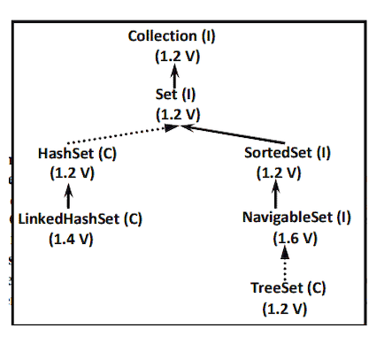
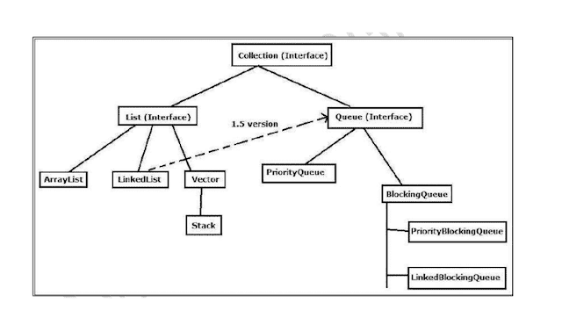
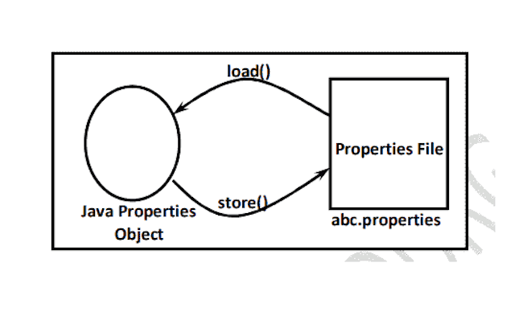
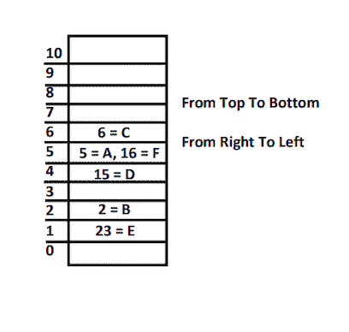
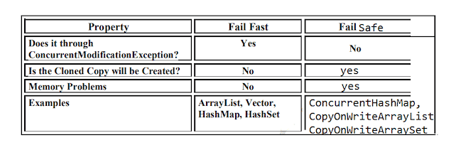
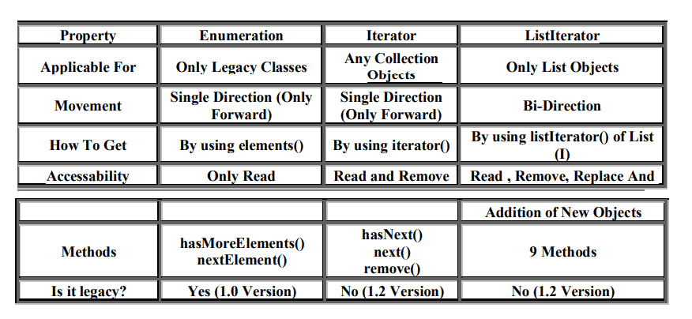

080 Serialization and DeSerialization 2

Serialization w.r.t Inheritance
===============================
Case 1:
If parent class implements Serializable then automatically every child class by
default implements Serializable.
That is Serializable nature is inheriting from parent to child.
Hence even though child class doesn't implements Serializable , we can serialize
child class object if parent class implements
serializable interface.
import java.io.Serializable;
import java.io.FileOutputStream;
import java.io.ObjectOutputStream;
import java.io.FileInputStream;
import java.io.ObjectInputStream;
import java.io.IOException;
class Animal implements Serializable{
int i=10;
}
class Dog extends Animal{
int j=20;
}
public class Test {
public static void main(String[] args)throws
IOException,ClassNotFoundException{
Dog d=new Dog();
System.out.println("Serialization started");
FileOutputStream fos=new FileOutputStream("abc.ser");
ObjectOutputStream oos=new ObjectOutputStream(fos);
oos.writeObject(d);
System.out.println("Serialization ended");
System.out.println("******************************");
System.out.println("DeSerialization started");
FileInputStream fis=new FileInputStream("abc.ser");
ObjectInputStream ois=new ObjectInputStream(fis);
Dog d1=(Dog)ois.readObject();
System.out.println(d1.i+"====> "+d1.j);
System.out.println("DeSerialization ended");
}
}
Output
Serialization started
Serialization ended
******************************
DeSerialization started
10====> 20
DeSerialization endedEven though Dog class does not implements Serializable interface explicitly but we
can Serialize Dog object because its parent class
Animal already implements Serializable interface.
Note :Object class doesn't implement Serializable interface.
Case 2:
1. Even though parent class does not implementsSerializable we can serialize child
object if child class implements Serializable
interface.
2. At the time of serialization JVM ignores the values of instance variables which
are coming
from non Serializable parent then instead of original value JVM saves default
values for those variables to the file.
3. At the time of Deserialization JVM checks whether any parent class is non
Serializable or not.
If any parent class is nonSerializable JVM creates a separate object for every
non Serializabl parent and
shares its instance variables to the current object.
4. To create an object for non-serializable parent JVM always calls no arg
constructor
(default constructor) of that non Serializable parent hence every non
Serializable parent should compulsory contain
no arg constructor otherwise we will get runtime exception
"InvalidClassException".
eg#1.
import java.io.Serializable;
import java.io.FileOutputStream;
import java.io.ObjectOutputStream;
import java.io.FileInputStream;
import java.io.ObjectInputStream;
import java.io.IOException;
class Animal {
int i=10;
Animal(){
System.out.println("No arg Animal constructor");
}
}
class Dog extends Animal implements Serializable{
int j=20;
Dog(){
System.out.println("No arg Dog constructor");
}
}
public class Test {
public static void main(String[] args)throws
IOException,ClassNotFoundException{
Dog d=new Dog();
d.i=888;
d.j=999;
System.out.println("Serialization started");FileOutputStream fos=new FileOutputStream("abc.ser");
ObjectOutputStream oos=new ObjectOutputStream(fos);
oos.writeObject(d);
System.out.println("Serialization ended");
System.out.println("******************************");
System.out.println("DeSerialization started");
FileInputStream fis=new FileInputStream("abc.ser");
ObjectInputStream ois=new ObjectInputStream(fis);
Dog d1=(Dog)ois.readObject();
System.out.println(d1.i+"====> "+d1.j);
System.out.println("DeSerialization ended");
}
}
Output
No arg Animal constructor
No arg Dog constructor
Serialization started
Serialization ended
******************************
DeSerialization started
No arg Animal constructor
10====> 999
DeSerialization ended
Agenda :
1. Externalization
2. Difference between Serialization & Externalization
3. SerialVersionUID
Externalization : ( 1.1 v )
1. In default serialization every thing takes care by JVM and programmer doesn't
have any control.
2. In serialization total object will be saved always and it is not possible to
save part of the object , which creates
performance problems at certain point.
3. To overcome these problems we should go for externalization where every thing
takes care by programmer and JVM
doesn't have any control.
4. The main advantage of externalization over serialization is we can save either
total object or part of the object based on
our requirement.
5. To provide Externalizable ability for any object compulsory the corresponding
class should implements externalizable
interface.
6. Externalizable interface is child interface of serializable interface.
Externalizable interface defines 2 methods :
1. writeExternal(ObjectOutput out ) throws IOException
2. readExternal(ObjectInput in) throws IOException,ClassNotFoundException
public void writeExternal(ObjectOutput out) throws IOException
This method will be executed automatically at the time of Serialization with in
this
method , we have to write code to save required variables to the file .
public void readExternal(ObjectInput in) throws IOException,ClassNotFoundExceptionThis method will be executed automatically at the time of deserialization with
in this
assign to the
current object.
method , we have to write code to save read required variable from file and
At the time of deserialization JVM will create a seperate new object by executing
public no-arg constructor
on that object JVM will call readExternal() method.
Every Externalizable class should compusory contains public no-arg constructor
otherwise we will get
RuntimeExcepion saying "InvaidClassException" .
eg#1.
import java.io.Serializable;
import java.io.FileOutputStream;
import java.io.ObjectOutputStream;
import java.io.FileInputStream;
import java.io.ObjectInputStream;
import java.io.IOException;
import java.io.Externalizable;
import java.io.ObjectOutput;
import java.io.ObjectInput;
class ExternalizableDemo implements Externalizable{
String i;
int j;
int k;
ExternalizableDemo(String i,int j,int k){
this.i=i;
this.j=j;
this.k=k;
}
}
public ExternalizableDemo(){
System.out.println("Zero arg constructor");
//Performing Serialization as per our requirement
public void writeExternal(ObjectOutput out) throws IOException{
System.out.println("call back method used while Serialization");
out.writeObject(i);
out.writeInt(j);
}
//Performing DeSerialization as per our requirement
public void readExternal(ObjectInput in) throws
IOException,ClassNotFoundException{
System.out.println("call back method used while DeSerialization");
i=(String)in.readObject();
j=in.readInt();
}
}
public class Test {
public static void main(String[] args)throws
IOException,ClassNotFoundException{ExternalizableDemo d=new ExternalizableDemo("nitin",100,200);
System.out.println("Serialization started");
FileOutputStream fos=new FileOutputStream("abc.ser");
ObjectOutputStream oos=new ObjectOutputStream(fos);
oos.writeObject(d);
System.out.println("Serialization ended");
System.out.println("******************************");
System.out.println("DeSerialization started");
FileInputStream fis=new FileInputStream("abc.ser");
ObjectInputStream ois=new ObjectInputStream(fis);
d=(ExternalizableDemo)ois.readObject();
System.out.println(d.i+"======>"+d.j+"======>"+d.k);
System.out.println("DeSerialization ended");
}
}
Output
Serialization started
call back method used while Serialization
Serialization ended
******************************
DeSerialization started
Zero arg constructor
call back method used while DeSerialization
nitin======>100======>0
DeSerialization ended
1. If the class implements Externalizable interface then only part of the object
will be saved in the case output is
2. public no-arg constructor
3. nitin---- 10 ----- 0
4. If the class implements Serializable interface then the output is nitin --- 10
--- 20
5. In externalization transient keyword won't play any role , hence transient
keyword not required.
Difference b/w Serialization and Externalization
================================================
Serialization
==========
1. It is meant for default Serialization
2. Here every thing takes care by JVM and programmer doesn't have any control
doesn't have any control.
3. Here total object will be saved always and it is not possible to save part of
the object.
4. Serialization is the best choice if we want to save total object to the file.
5. relatively performence is low.
6. Serializable interface doesn't contain any method
7. It is a marker interface.
8. Serializable class not required to contains public no-arg constructor.
9. transient keyword play role in serialization
Externalization============
1. It is meant for Customized Serialization
2. Here every thing takes care by programmer and JVM does not have any control.
3. Here based on our requirement we can save either total object or part of the
object.
4. Externalization is the best choice if we want to save part of the object.
5. relatively performence is high
6. Externalizable interface contains 2 methods :
1. writeExternal()
2. readExternal()
7. It is not a marker interface.
8. Externalizable class should compulsory contains public no-arg constructor
otherwise we will get
RuntimeException saying "InvalidClassException"
9. transient keyword don't play any role in Externalization.
serialVersionUID
================
=> To perform Serialization & Deserialization internally JVM will use a unique
identifier,which is nothing but serialVersionUID .
=> At the time of serialization JVM will save serialVersionUID with object.
=> At the time of Deserialization JVM will compare serialVersionUID and if it is
matched then only object will be
Deserialized otherwise we will get RuntimeException saying
"InvalidClassException".
The process in depending on default serialVersionUID are :
1. After Serializing object if we change the .class file then we can't perform
deserialization because of mismatch in
serialVersionUID of local class and serialized object in this case at the
time of Deserialization we will get
RuntimeException saying in "InvalidClassException".
2. Both sender and receiver should use the same version of JVM if there any
incompatability in JVM versions then
receive unable to deserializable because of different serialVersionUID , in
this case receiver will get
RuntimeException saying "InvalidClassException".
3. To generate serialVersionUID internally JVM will use complexAlgorithm which may
create performence problems.
We can solve above problems by configuring our own serialVersionUID .
eg#1.
import java.io.Serializable;
public class Dog implements Serializable {
private static final long serialVersionUID=1L;
int i=10;
int j=20;
}
import java.io.*;
public class Sender {
public static void main(String[] args)throws IOException {
Dog d=new Dog();
FileOutputStream fos=new FileOutputStream("abc.ser");
ObjectOutputStream oos=new ObjectOutputStream(fos);
oos.writeObject(d);}
}
import java.io.*;
public class ReceiverApp {
public static void main(String[] args) throws
IOException,ClassNotFoundException{
FileInputStream fis=new FileInputStream("abc.ser");
ObjectInputStream ois=new ObjectInputStream(fis);
Dog d2=(Dog) ois.readObject();
System.out.println(d2.i+"=====>"+d2.j);
}
}
D:\TestApp>javac Dog.java
D:\TestApp>java Sender
D:\TestApp>javac Dog.java
D:\TestApp>java ReceiverApp
10=====>20
=> In the above program after serialization even though if we perform any change to
Dog.class file we can deserialize object.
=> We can configure our own serialVersionUID both sender and receiver not required
to maintain the same JVM versions.
Note : some IDE's generate explicit serialVersionUID.
Usage of StringTokenzier
====================
=> It is a part of java.util package
=> It is used to split the entire string into mulitple tokens based on the
delimiter we supply
eg: String data= "sachin ramesh tendulkar";
StringTokenzier stk = new StringTokenizer(data);
StringTokenzier stk = new StringTokenizer(data," ");
=> public boolean hasMoreTokens()
=> public String nextToken()
eg#1.
import java.util.*;
class TestApp {
public static void main(String[] args) {
StringTokenizer stk = new
StringTokenizer("sachin$ramesh$tendulkar","$");
System.out.println(stk);
int tokenCount = stk.countTokens();
System.out.println(tokenCount);
while (stk.hasMoreTokens())
{
String data = stk.nextToken();
System.out.println(data);
}
}
}
